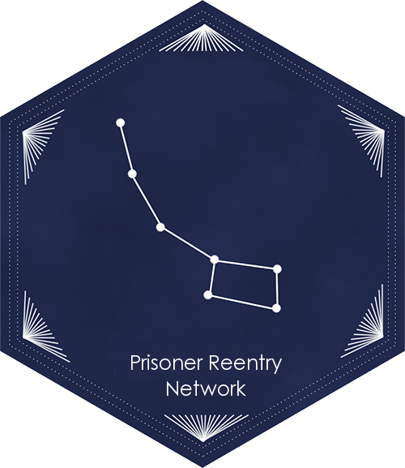
Transportation from
Centinela, Chuckawalla, Calipatria, High Desert, CVSP, Ironwood, and California Correctional Center

Directions to the Bay Area, Central California (Sacramento to Bakersfield), and Southern California (LA and San Diego)

Updated: 9.2.15
CONTENTS:
- LEAVING PRISON  - Indio Greyhound Station  - Reno Amtrak Station  - BUSES FROM EL CENTRO TO THE BAY AREA  - Travel in the Bay Area Using BART  - BUSES FROM EL CENTRO TO SACRAMENTO  - BUSES FROM EL CENTRO TO BAKERSFIELD  - BUSES FROM EL CENTRO TO SAN DIEGO | - BUSES FROM EL CENTRO TO LOS ANGELES  - Travel around Los Angeles using Metrolink  - PURCHASING TICKETS AT AMTRAK STATIONS  - DIRECTIONS FROM RENO AMTRAK  - EMERGENCY SERVICES

Getting home from Prison can be difficult and expensive, and you may have no more than $200 to pay for the return trip. This guide is intended to provide information on transportation options from Centinela, Chuckawalla, Calipatria, and CCC.

LEAVING PRISON
On the day of your release, you will be taken to Receiving and Release, where you will be provided clothing, identification, and gate money. They will then take you to the Indio Greyhound Station. If you are leaving CCC Susanville, you may be taken to the Reno Amtrak station.

Clothing: The prison will provide you clothes for your release. There are some clothes that have been donated, and you also may purchase clothes from PIA using your gate money. The clothes cost approximately $30.

If someone has sent dressouts, they will be waiting for you at Receiving and Release. An individual must send the items thirty days prior to your release, write “dressouts” as well as the person they are being delivered to.
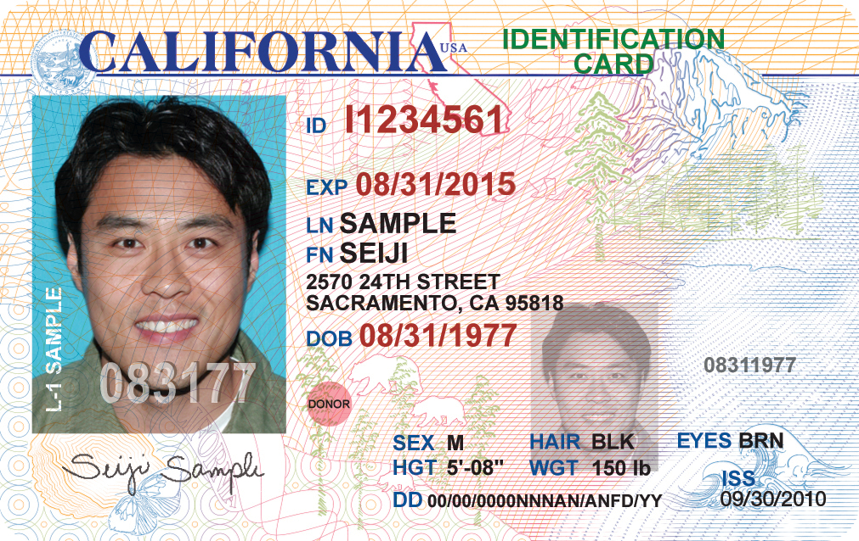
Identification: You may keep your CDCR-issued identification, and this will likely be the only identification available. However, recent legislation has required CDCR and DMV to supply individuals leaving prison with identification. The California Department of Corrections and Rehabilitation and the Department of Motor Vehicles to ensure that inmates released from state prisons have valid identification cards (pictured right).

If you are leaving prison, and you meet all the following requirements:
- Previously held a CA driver’s license or ID card.
- Have a usable photo on file with the DMV that is not more than 10 years old.
- No outstanding fees due for a prior CA identification card.
- DMV verified your name, date of birth, social security number, and legal presence in the US.
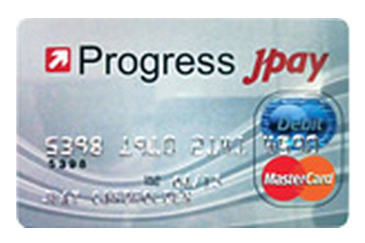
Then, you should get an identification card. Prior to release, speak with your counselor about getting your CA ID. Identification is in important to get public benefits, housing, and other important necessities.

Gate Money: Many CDCR facilities no longer give cash at the gate release. Instead, they are issuing debit cards as gate money (pictured left). This debit card should have your $200 gate money, in addition to the money in your trust account.

Asking for help: “My advice would be to ask for help. I asked for directions from anybody I could once I got to San Francisco. I actually asked directions from three police officers. I left with another guy, and he was freaking when I approached the police. I told him, ‘Relax we’re not doing anything – we’re free.’” – Mark Self, released from Solano 2015.

Electronic Tellers: Americans now purchase many items from electronic tellers. “The weirdest experience I had was going to a store and there were no tellers – just go in in and check yourself out. That was crazy,” recalled Daron Jones, who served thirty years and was released in 2015. Electronic tellers are discussed extensively in this packet.
Indio Greyhound Station: If you do not have someone scheduled to pick you up, you will most likely be taken to the Indio Greyhound Station at 460 West State Street, El Centro, CA. The Indio Greyhound station looks like this:
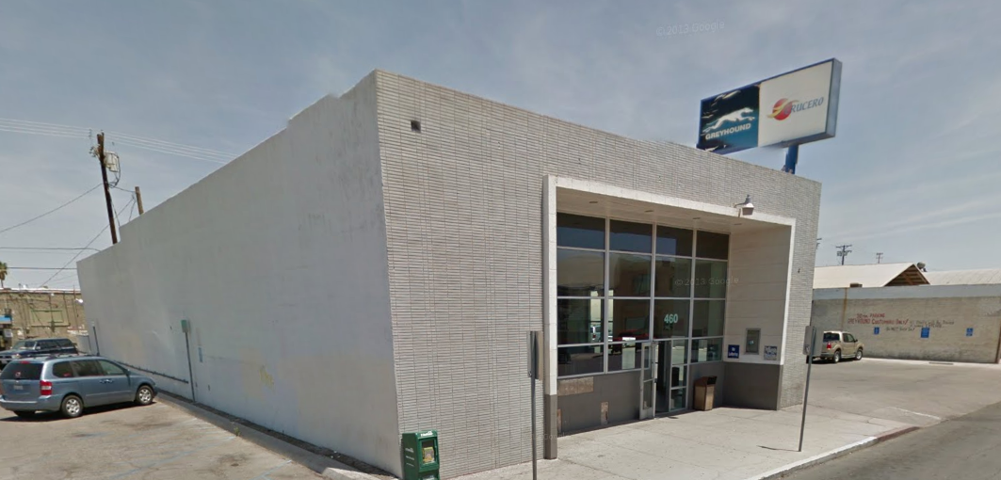

Reno Amtrak Station: If you are leaving CCC, Susanville during the day, you will be taken to the Reno Amtrak Station, where you must get on a bus or train. It looks like this:

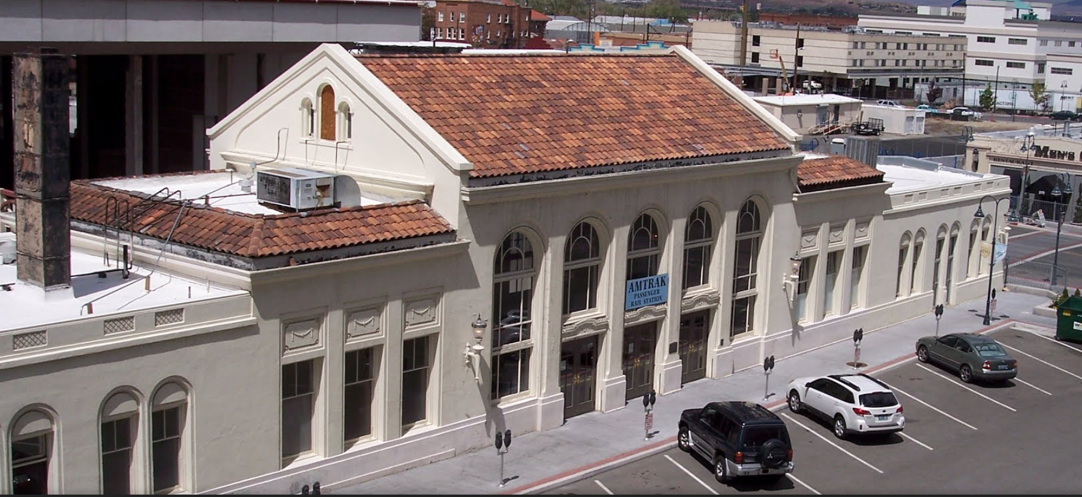
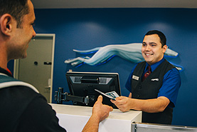
PURCHASING GREYHOUND TICKETS FROM AN AGENT
At the Greyhound station there will likely be a uniformed ticket agent at the counter (see right). They will help you buy a ticket to wherever you are going. You may have to get off the bus and onto other buses on your trip. If possible make sure you buy all tickets needed for your Greyhound trip at your first Greyhound station, rather than purchasing separate tickets at each stop, however do what the ticket agent instructs.

PURCHASING TICKETS USING THE GREYHOUND KIOSK MACHINE
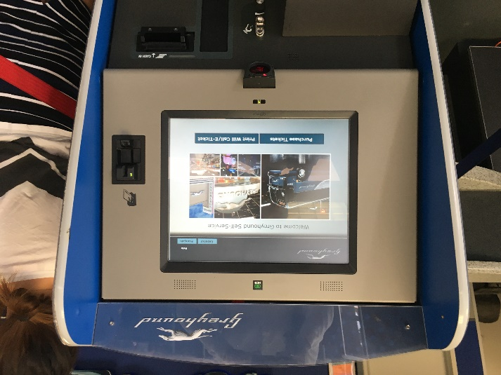
If the Bus/Greyhound station you are at does not have a ticket office/agent, you can purchase bus and train tickets at the Greyhound kiosk machine as shown to the left. You may have to get off the bus and onto other buses on your trip. If possible make sure you buy all tickets needed for your Greyhound trip at your first Greyhound station, rather than purchasing separate tickets at each station you stop at.

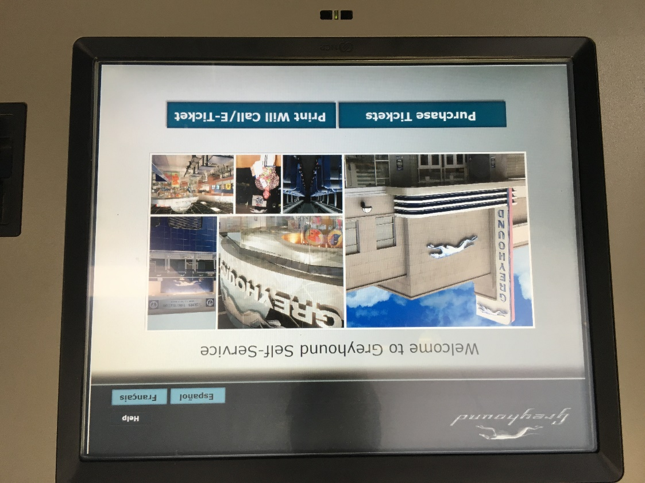
The Greyhound kiosk machine uses a touch screen. To purchase tickets using the Greyhound kiosk machine, follow these instructions:

Press the Purchase Tickets button.

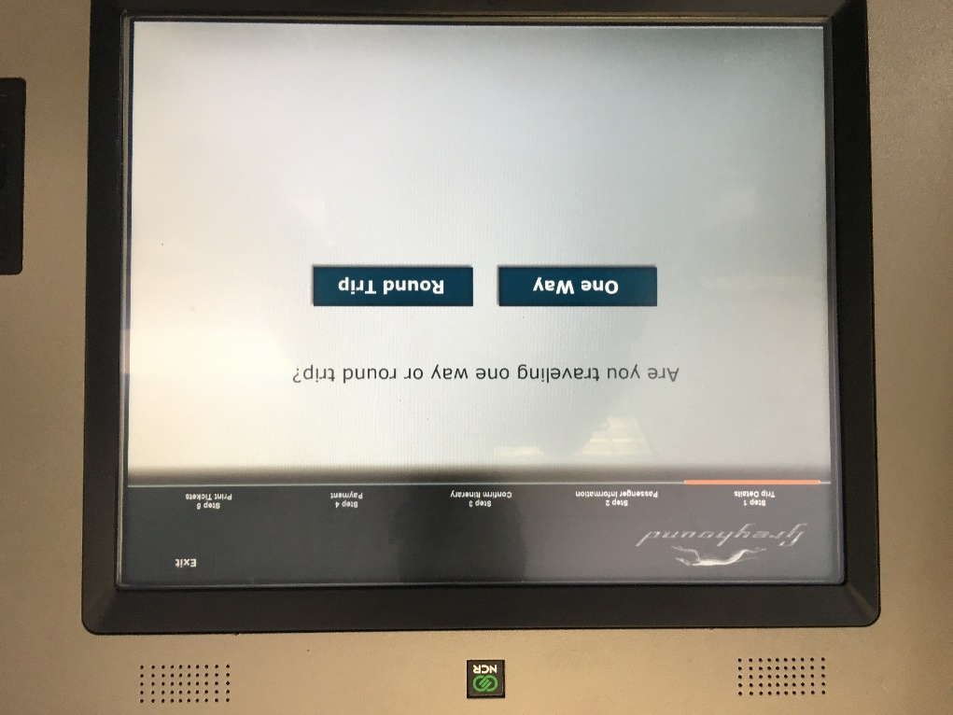

Press the One Way button.

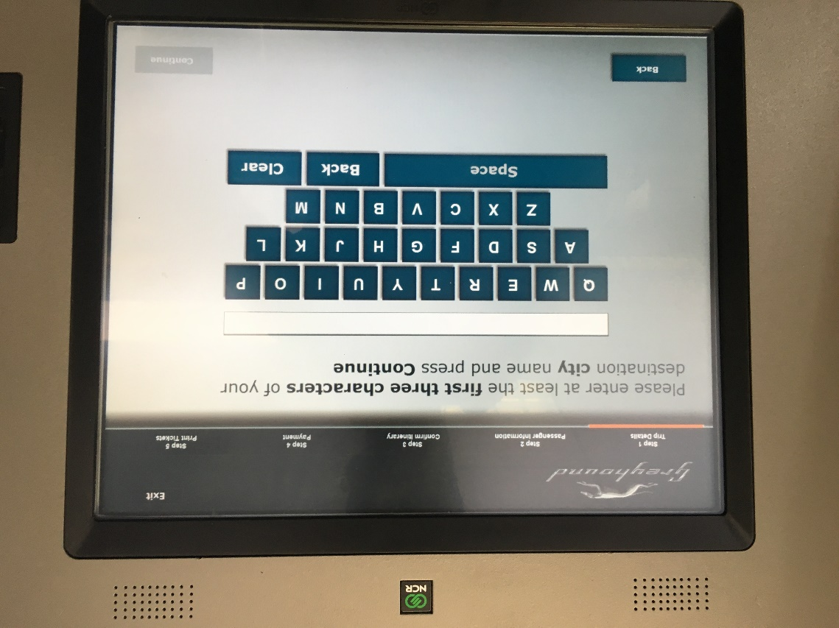

Press the first three letters of your destination, the press the Continue button in the bottom right corner.

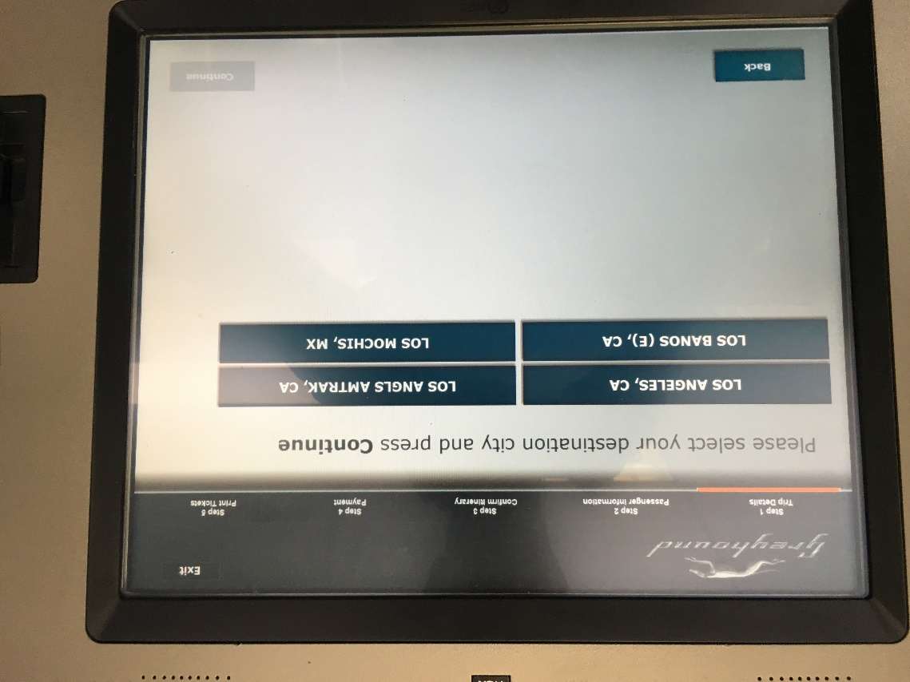

Press your destination on the screen and then press the Continue button in the bottom right corner.

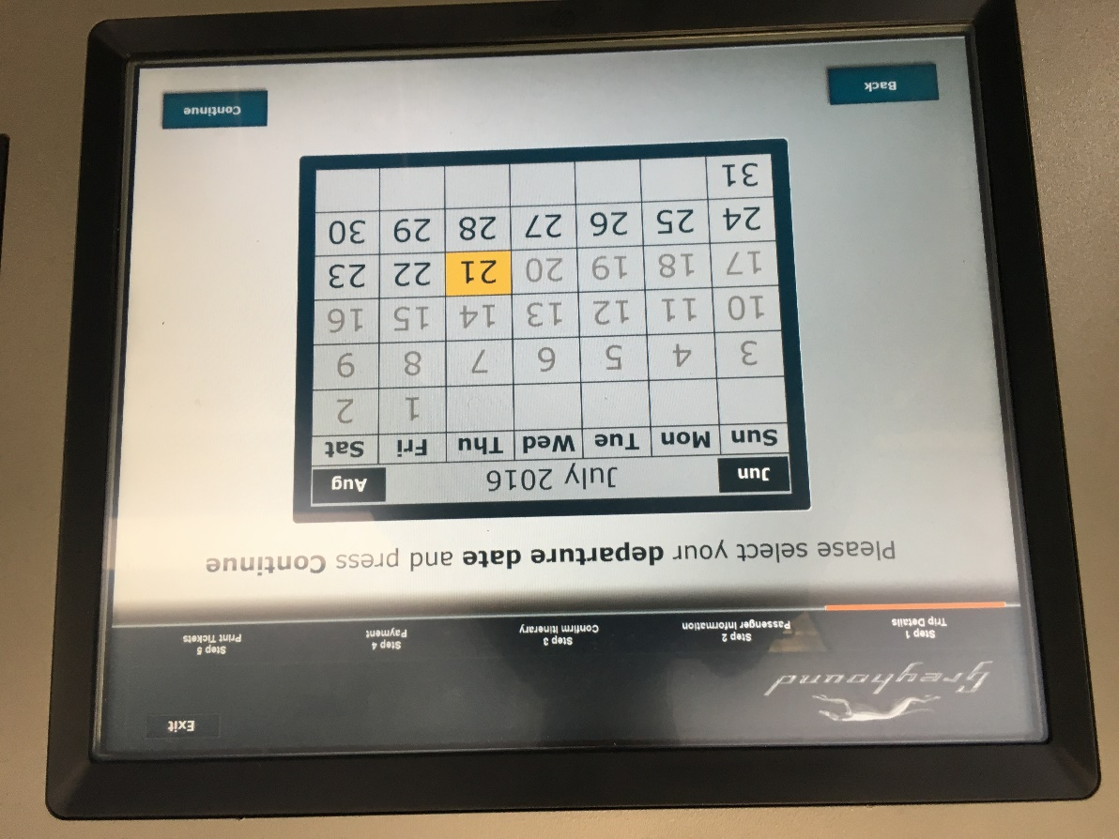
Press your departure date (probably today’s date) and then press the Continue button.

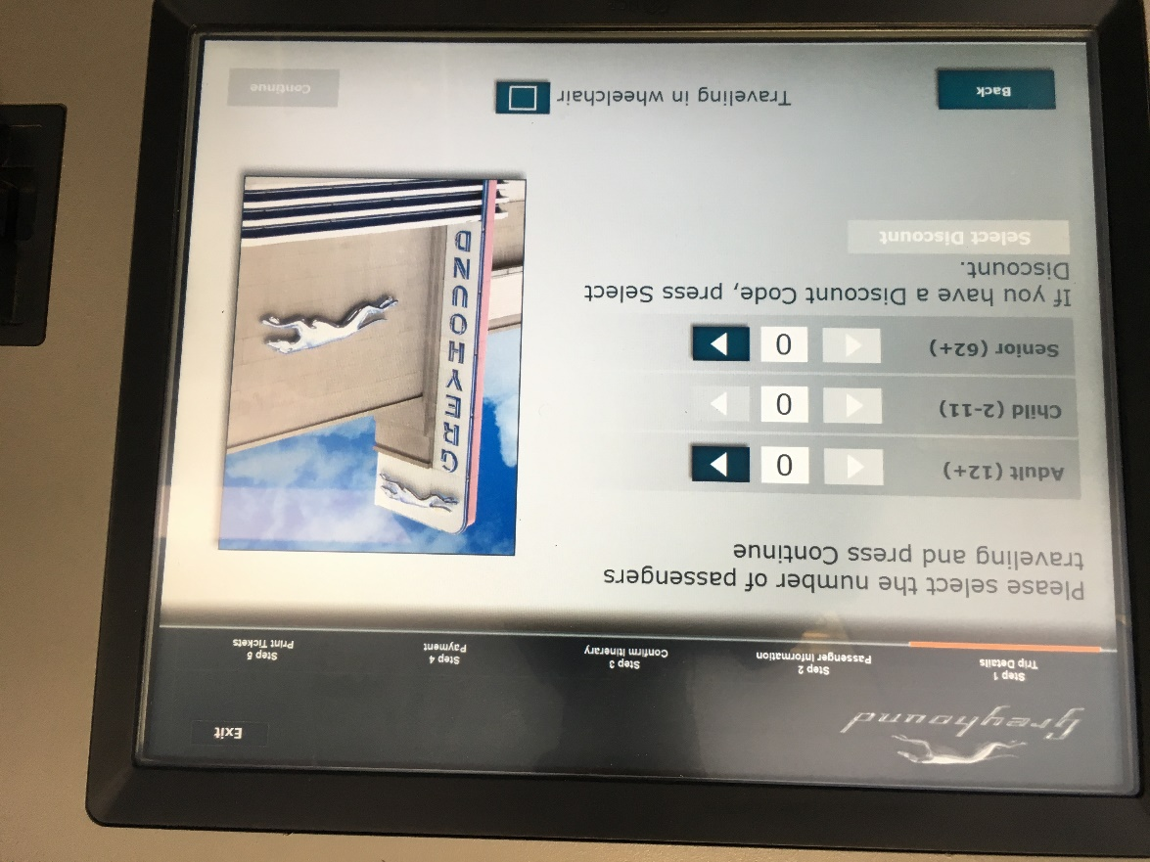

Press the > (arrow) button next to the type of tick you would like to buy. Then press the Continue button.

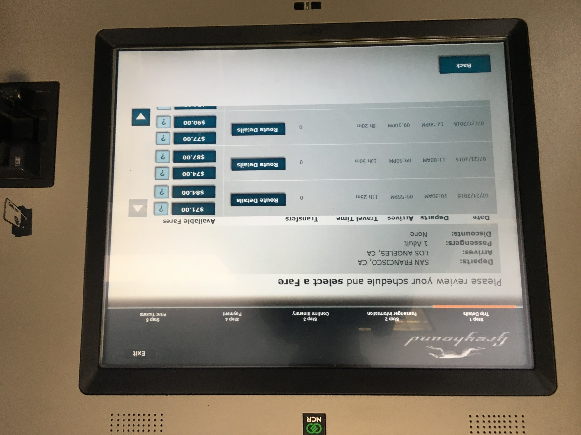

Press the least expensive price of the trip you would like to take. When the machine asks “Would you like to accept this fare?” press Accept.

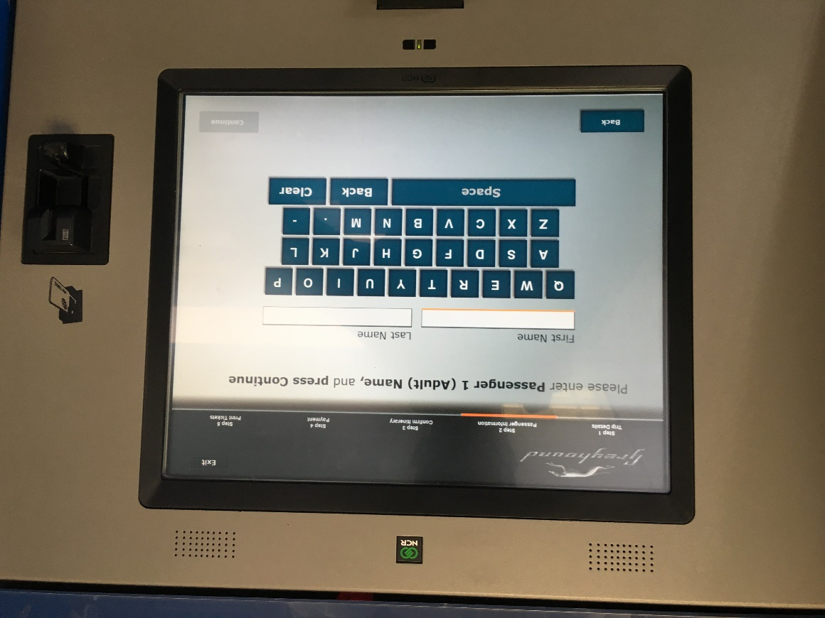
Type your first and last name into the machine. Then press the Continue button. It will then ask you to “Review your Itinerary and Charges.” Make sure everything is as you want it to be then press the Continue button. It will then take you to “Terms and Conditions.” Press the Accept button in the bottom right corner.

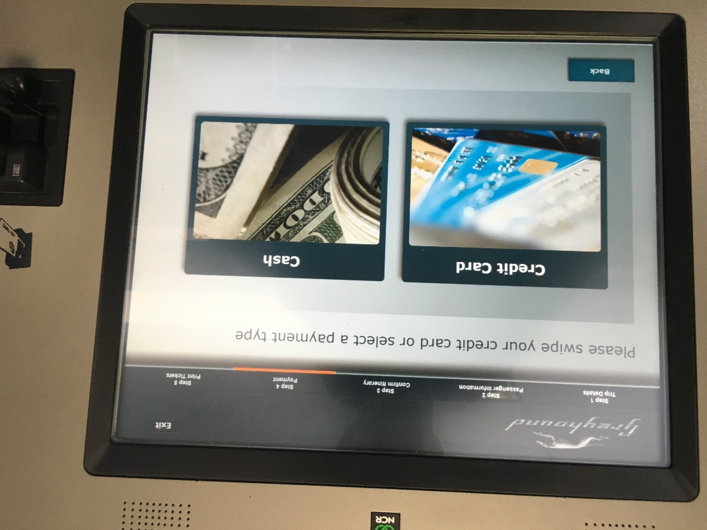

Press the way you would like to pay. This likely with “credit card” unless you have cash. You can use the card CDCR provided upon release.

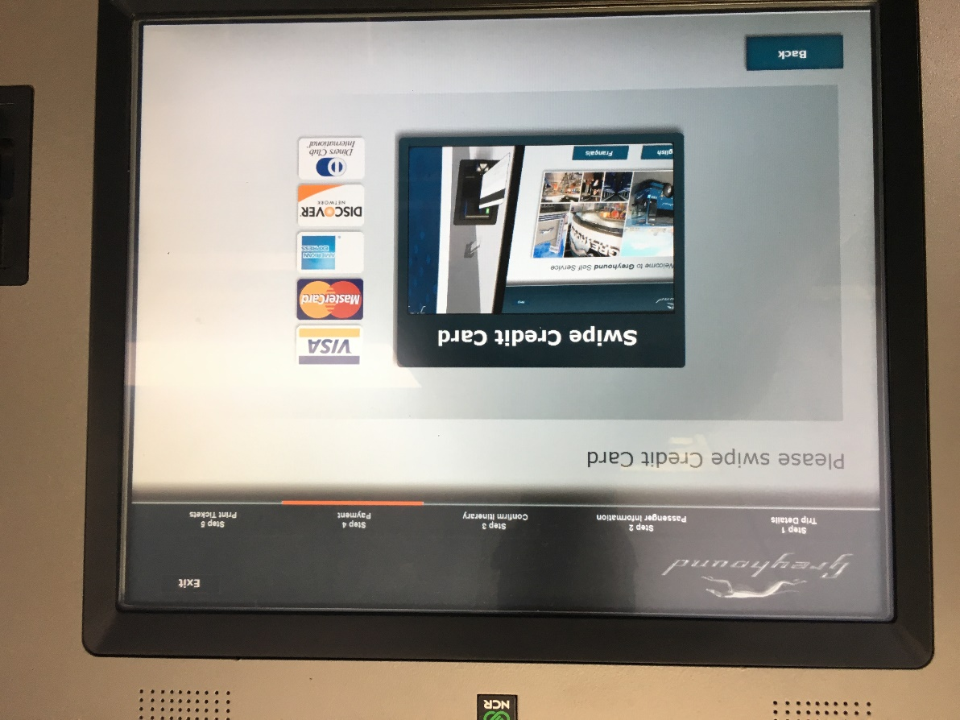
Swipe your card in the slot on the right of the machine the way shown in the picture. Your ticket should print and be delivered below the screen.

Congratulations! You’re on your way.
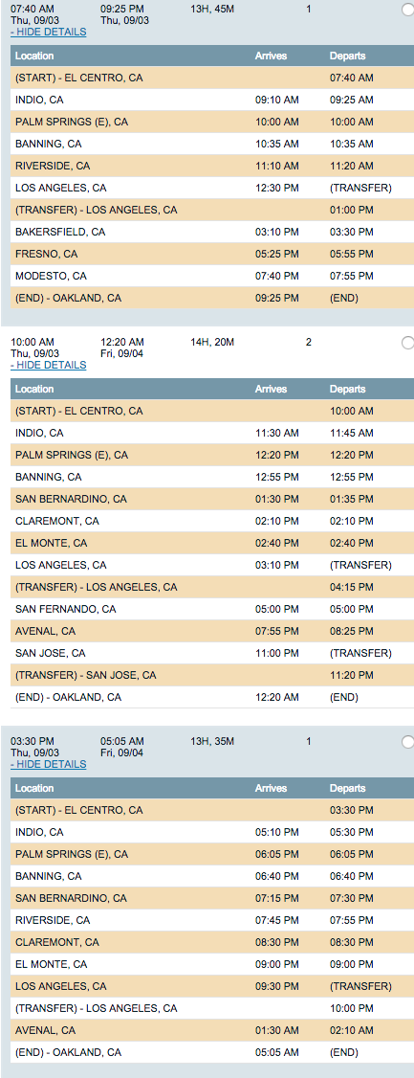
Buses to the Bay Area: Travel by bus to Bay Area costs approximately $142, and will take fourteen hours. Buses leave at 7:40 am, 10:00 am, and3:30 pm. Here is the schedule:

TRAVEL IN THE BAY AREA USING BART: Once you are in Richmond, you can transfer to BART. BART stands for Bay Area Rapid Transit.
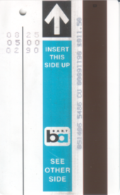
BART CARD: This a BART card (pictured right). Insert it into the turnstile (pictured below) on both entry and exit.

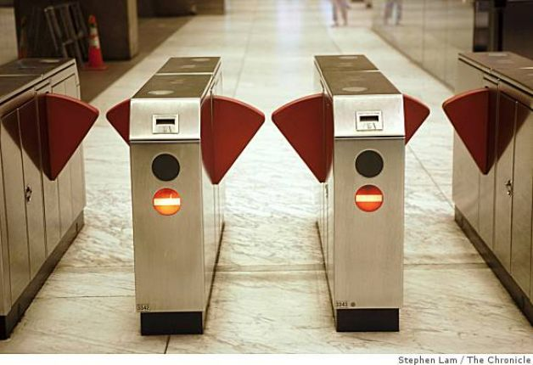

Once you exit, the funds are removed based on the length of your travel. You can know how much money remains on your card by looking next to the arrow, where the remaining amount is printed.

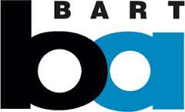
The BART logo looks like this:

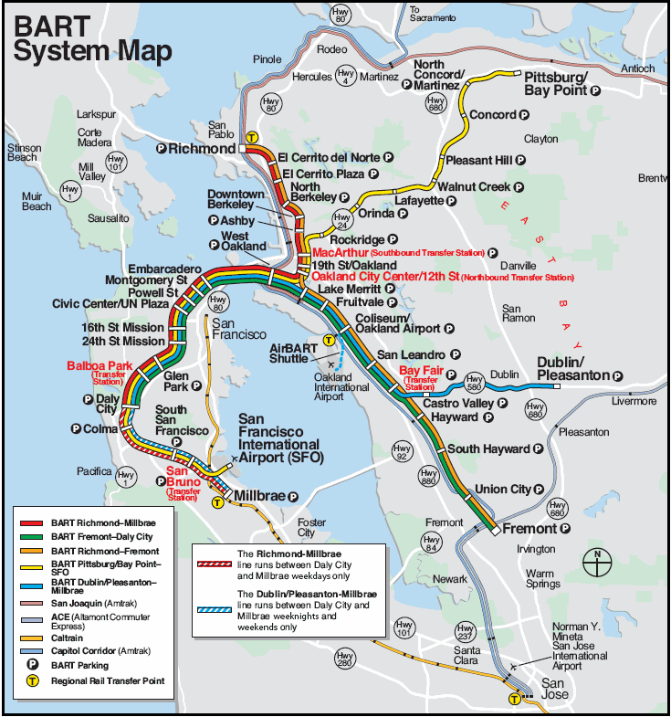
The BART system is complicated, but you can get to most destinations in the Bay Area.

Buses to Sacramento: Travel to Sacramento by Greyhound costs approximately $114 and takes over twelve hours. Buses leave at 7:40 am, 10:00 am, 11:00 am, 3:30 pm, and 8:35 pm. Here are the schedules:
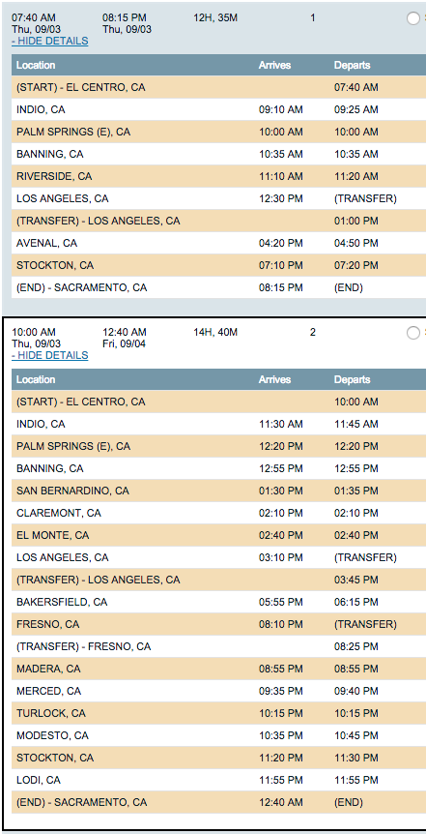
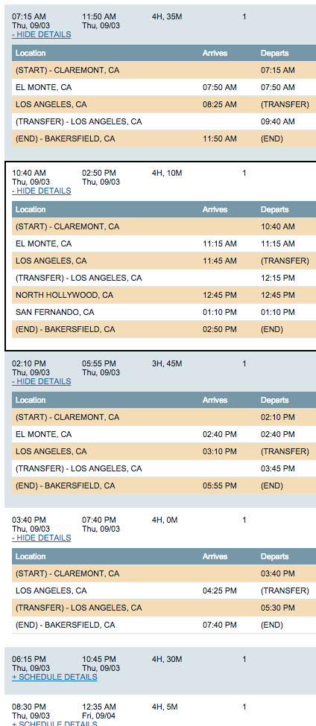
Buses to Bakersfield: Travel to Bakersfield costs approximately $19 and the trip takes four hours. Buses leave at 7:15 am, 10:40 am, 2:10 pm 3:40 pm, 6:15 pm, and 8:30 pm. Here is the schedule:

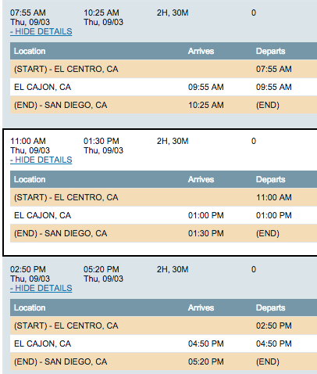
Buses to San Diego: Travel to San Diego will take approximately two and a half hours and costs $28. Buses leave at 7:55 am, 11:10 am, 2:50 pm. Here is the schedule:

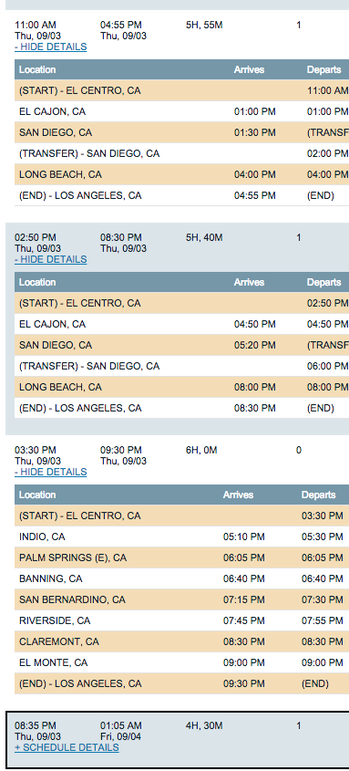
Travel to Los Angeles using Metrolink : To get to Los Angeles, take any of the trains above. The cost is approximately $18, and will take one hour.
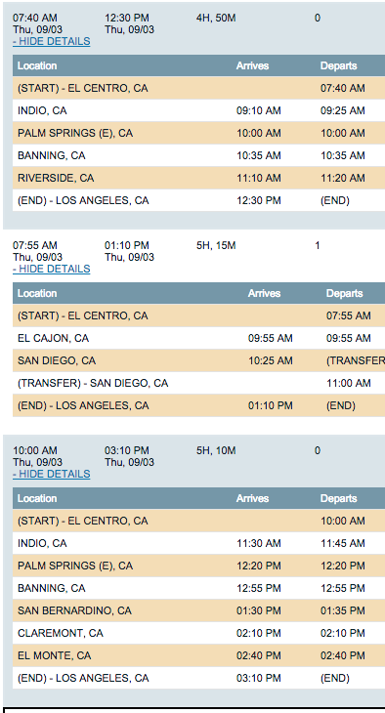

TRAVEL AROUND LOS ANGELES AREA USING METROLINK:

Once you make it to Los Angeles, you can get around the area using MetroLink:

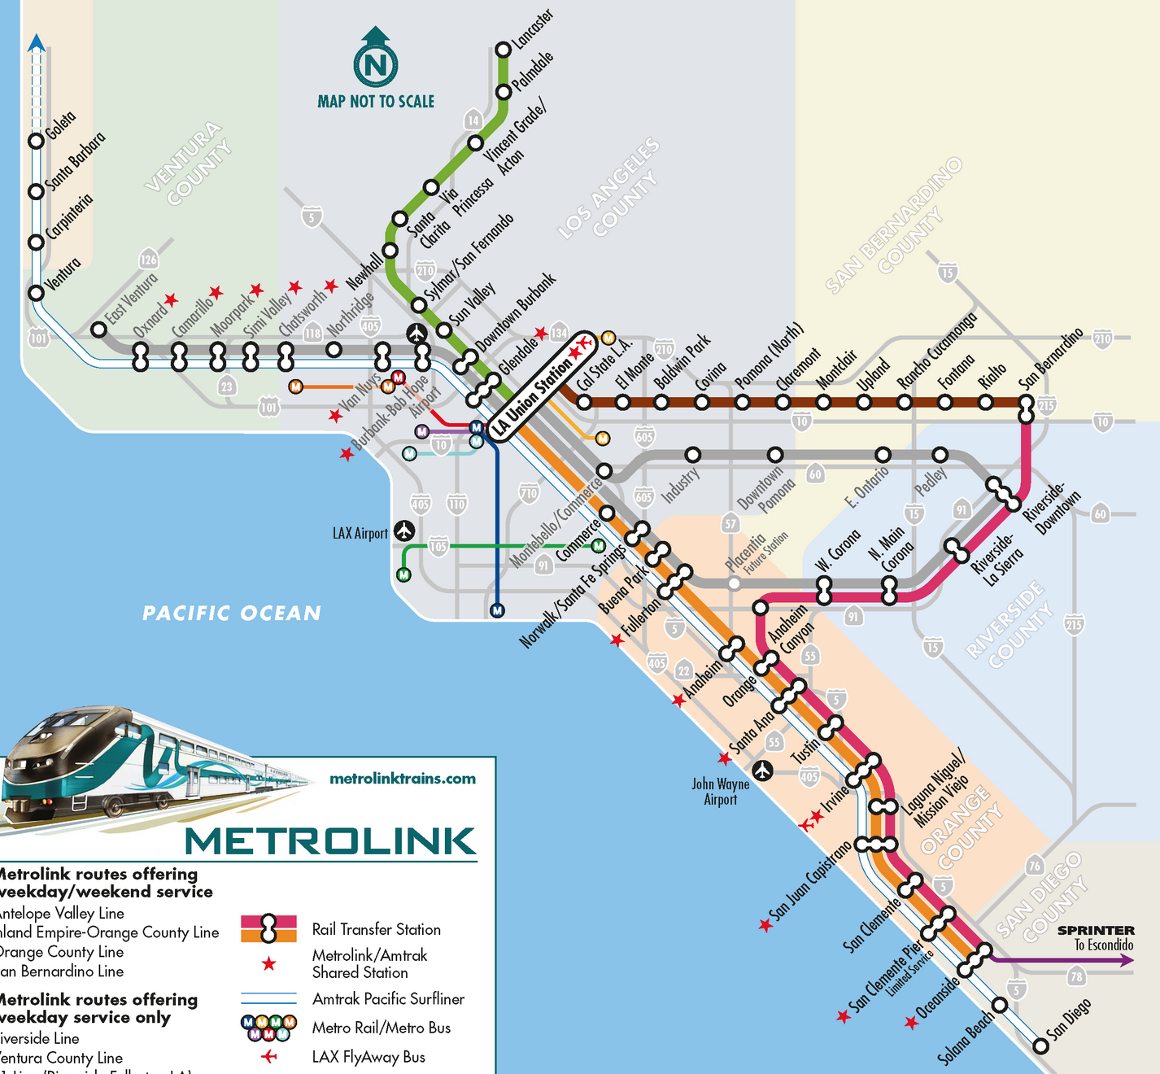

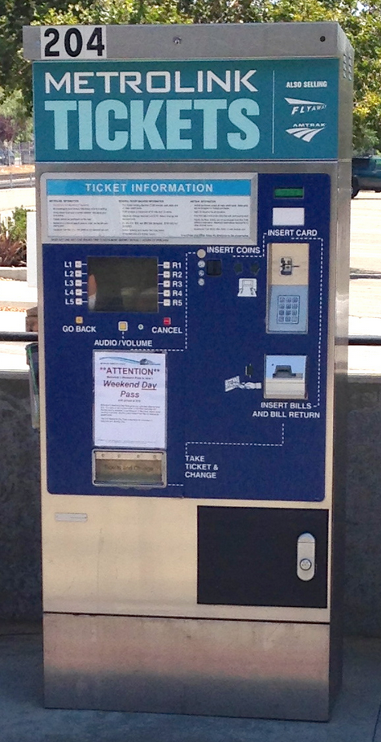
Purchasing Metrolink Tickets with Ticketing Machine:
Metrolink tickets are not sold onboard the train, and must be purchased prior to barding the train. Ticket vending machines (pictured right) are located on Metrolink train platforms. To purchase a ticket, follow these instructions:
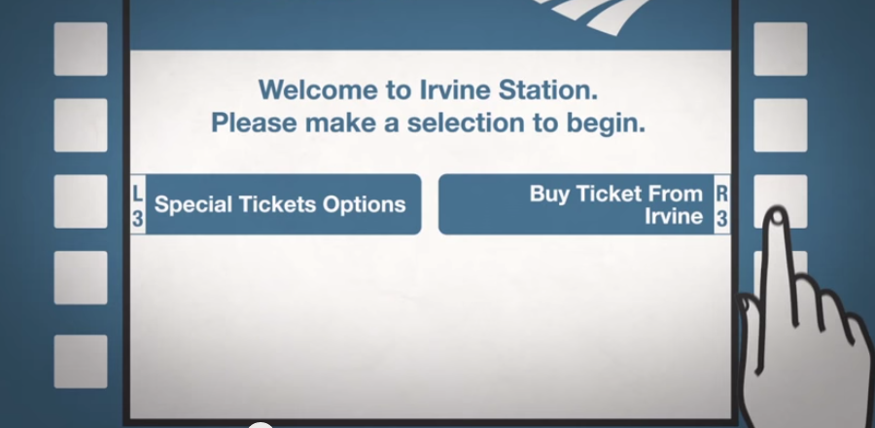
Step 1: Using the buttons surrounding this screen, select “Buy Ticket From Los Angeles”

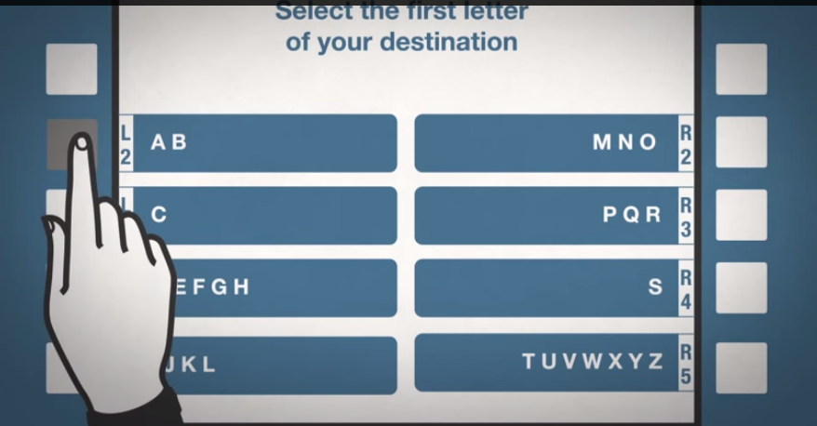
Step 2: Select the first letter of your destination.

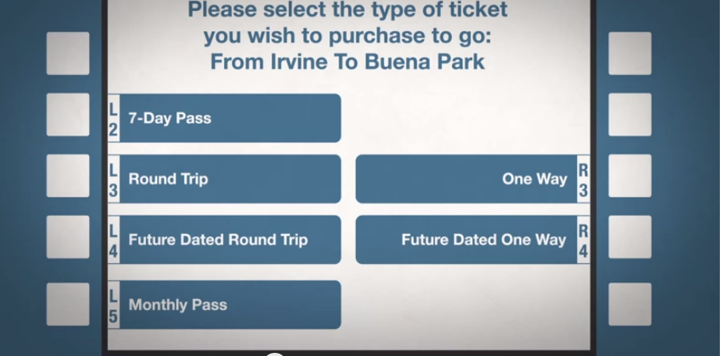

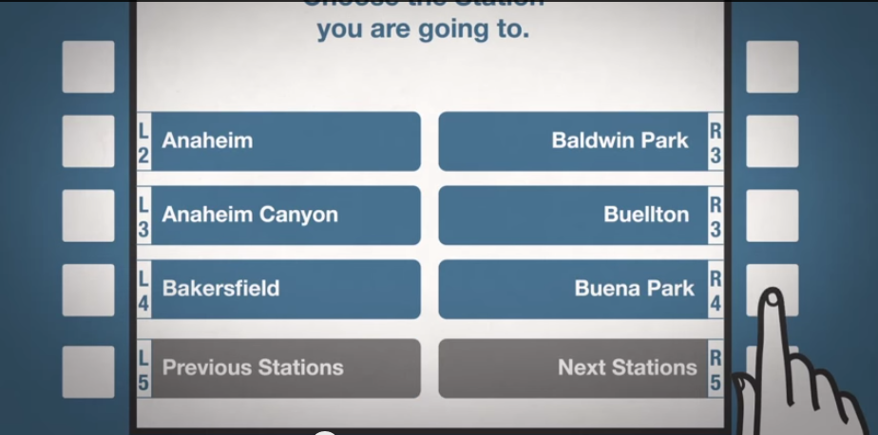
Step 3: Select your destination.

Step 4: Select One Way trip.

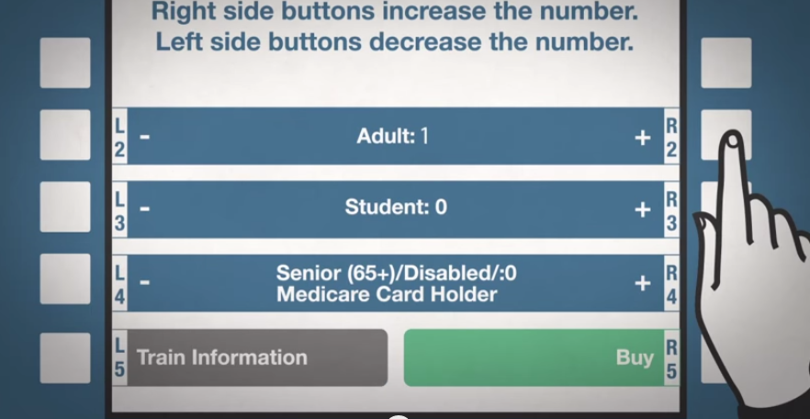
Step 5: Select the ticket type. If you are over 65 or disabled, be sure to get a reduced fee ticket.

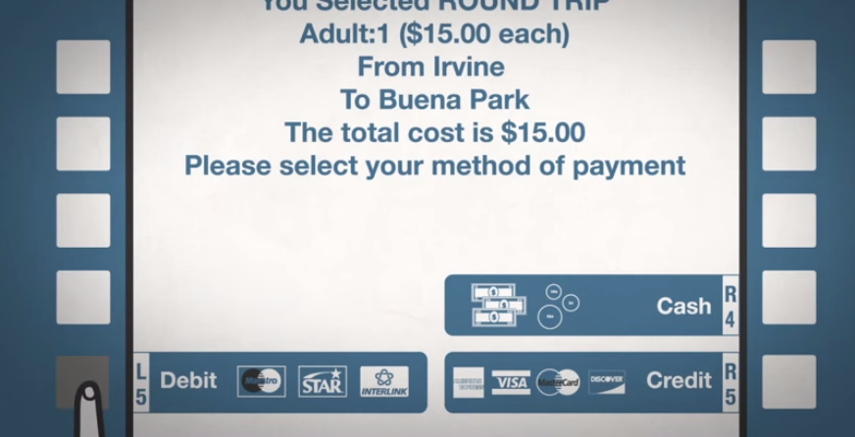
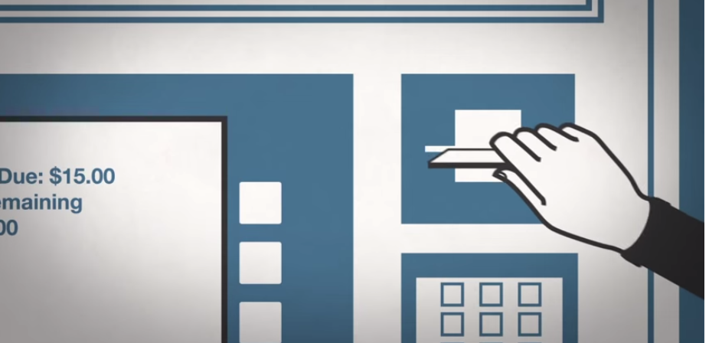
Step 6: Select “Credit” as your payment type and put your gate money card into the machine.
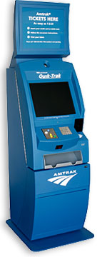
PURCHASING TICKETS AT AN AMTRAK STATION USING A TICKET MACHINE
If you make it to an Amtrak station, there may be an electronic kiosk where you can purchase bus and train tickets (pictured left). Make sure you buy a ticket all the way to your final destination, rather than purchasing separate tickets for each leg of the journey.

The Quik-Trak machine uses a touch screen. To purchase tickets using the Quick-Trak Machine, follow these instructions:
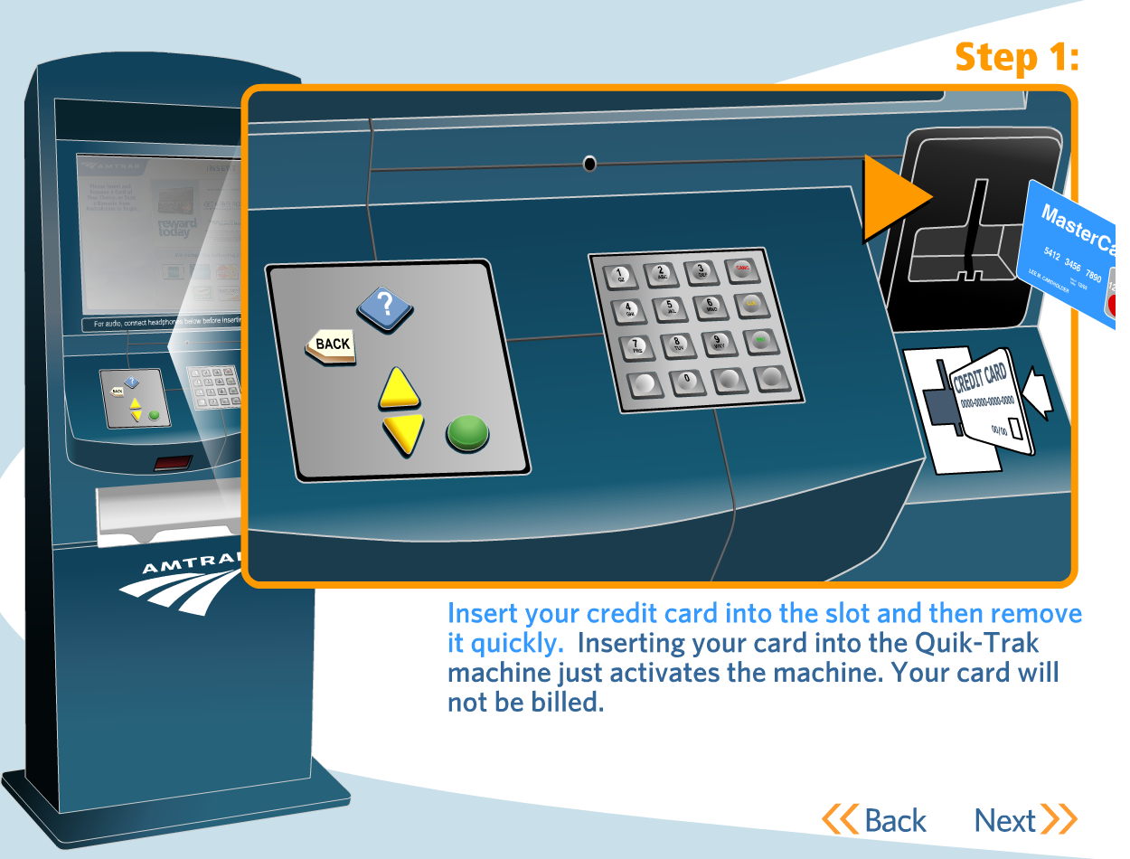

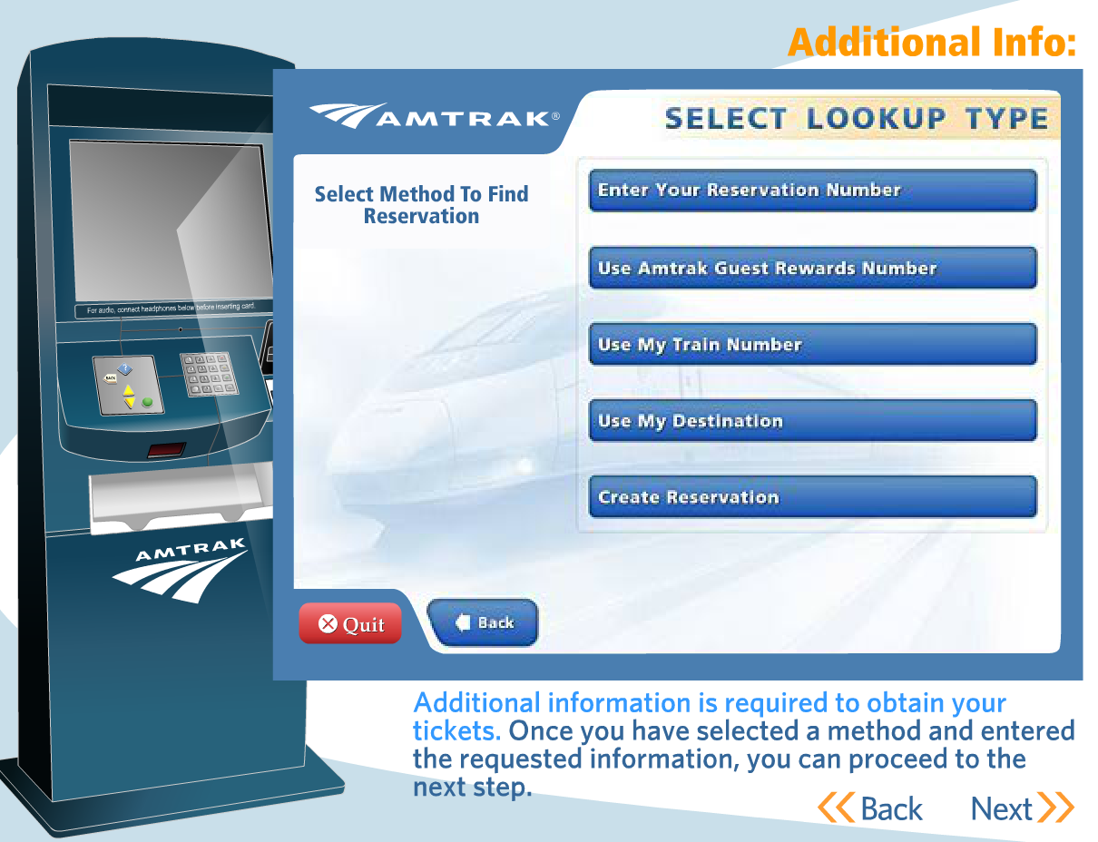

Step 2: Touch “Create Reservation” and select the location where you would like to go, and when.

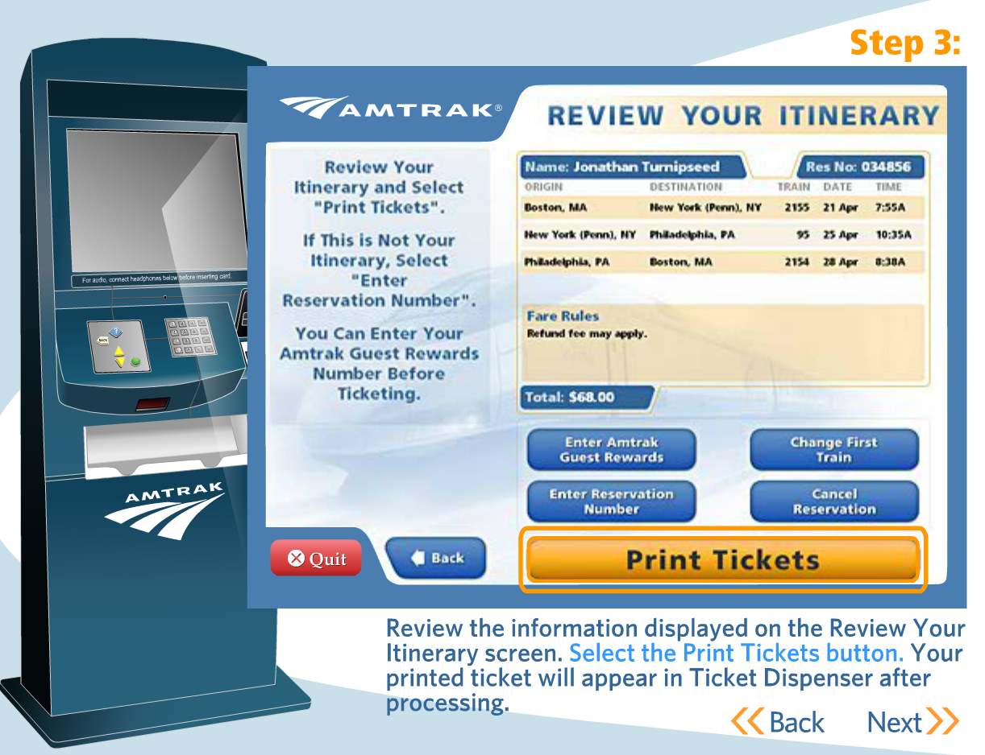

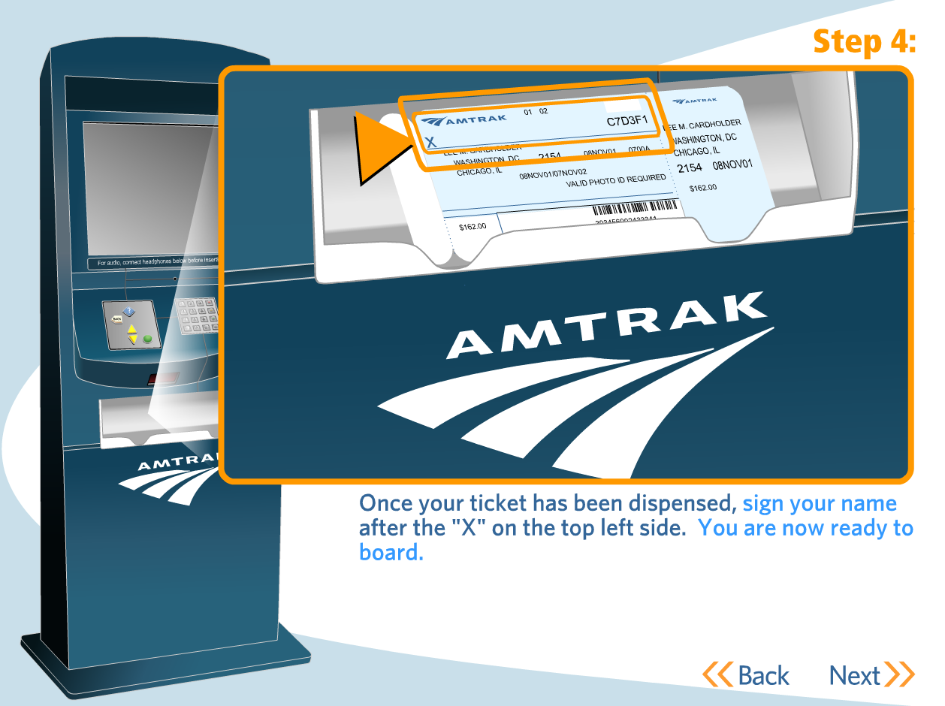

UNDERSTANDING YOUR AMTRAK TICKET AND TRIP
Your Amtrak ticket should look like one of the following shown below. They list your name, departure and arrival location, departure and arrival time. To find the boarding gate where your train is leaving ask an Amtrak employee or look for a monitor that lists it. These monitors will usually list the boarding gate 15 minutes before the departure time of the train. Make sure to get on your train as soon as possible - some trains will not let you on if you don’t board 10 minutes before the departure time. You may have to get on multiple trains to get to your destination. For part of your Amtrak trip you may have to take a Thruway Bus. If you cannot find something make sure to talk to people. Try to find someone who works at Amtrak, but you can always ask for help from a stranger.
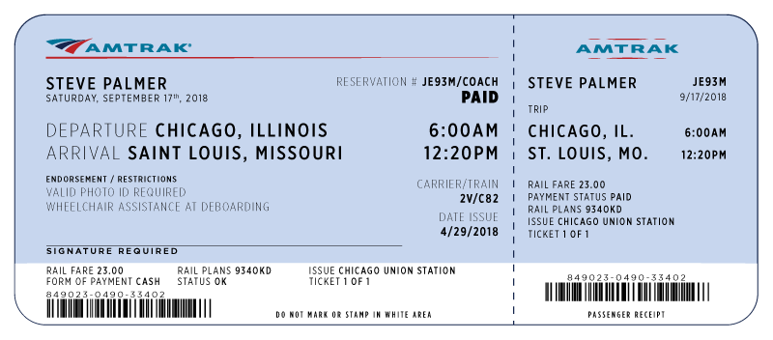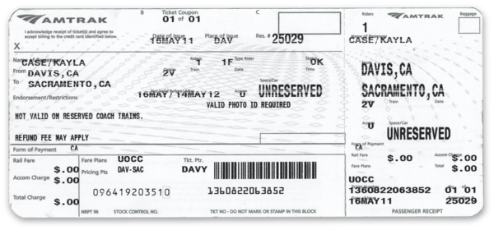
FROM RENO AMTRAK:

To get from Reno to the Bay Area, the most reliable route is to take a train to Richmond, which also serves as a BART station. There is a direct train from Reno that leaves at 8:36am, and you’ll arrive at 3:59pm. It should cost $50. Here is the schedule:

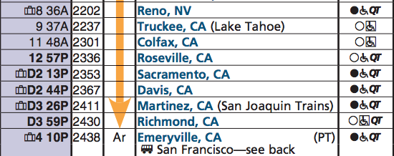

If you do not get to the Reno Amtrak station early enough to catch this train, you can get a bus to Sacramento and then take a train from there. Here is the schedule and cost:
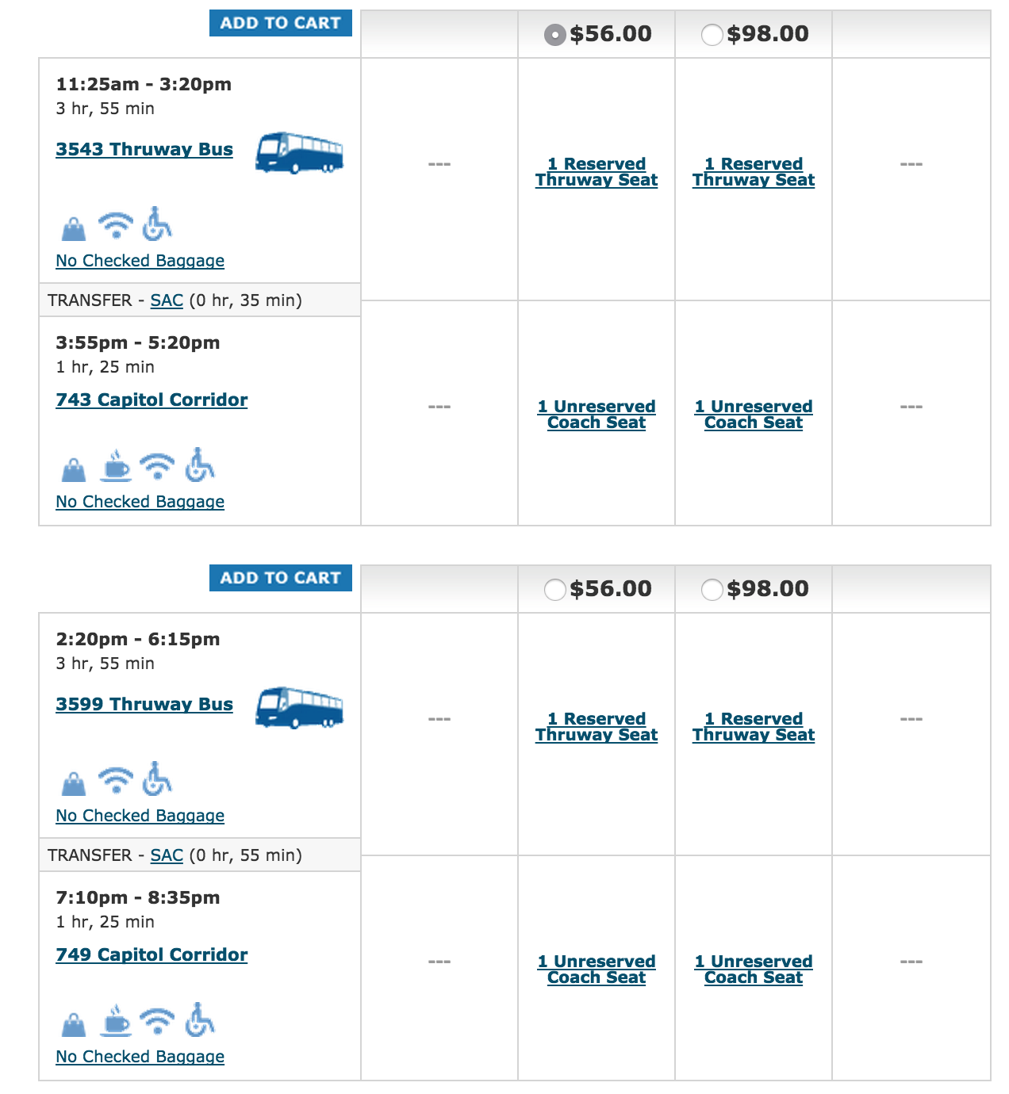
TO SACRAMENTO BY TRAIN: TRAINS FROM RENO AMTRAK STATION TO SACRAMENTO
To get from Reno to Sacramento there is a direct train from Reno that leaves at 8:36am, and you’ll arrive at 2:13pm. It should cost $45. Here is the schedule:

If you do not get to the Reno Amtrak station early enough to catch this train, you can get a bus to Sacramento. Here is the schedule:

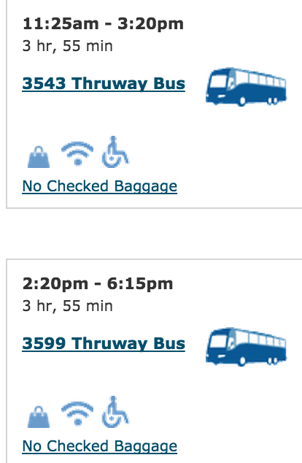

TO BAKERSFIELD BY TRAIN: TRAINS FROM RENO AMTRAK STATION TO BAKERSFIELD
To get to Bakersfield, get to Sacramento. Purchase tickets all the way to Bakersfield, but know that your first stop will be Sacramento. Once you get to Sacramento’s train station, get on the San Joaquin at 10:25am, 1:25pm, 4:55pm, or 6:25pm. It should cost $67 if you take a bus to Sacramento, and $90 if you take a train. The train schedule from Sacramento to Bakersfield is below.

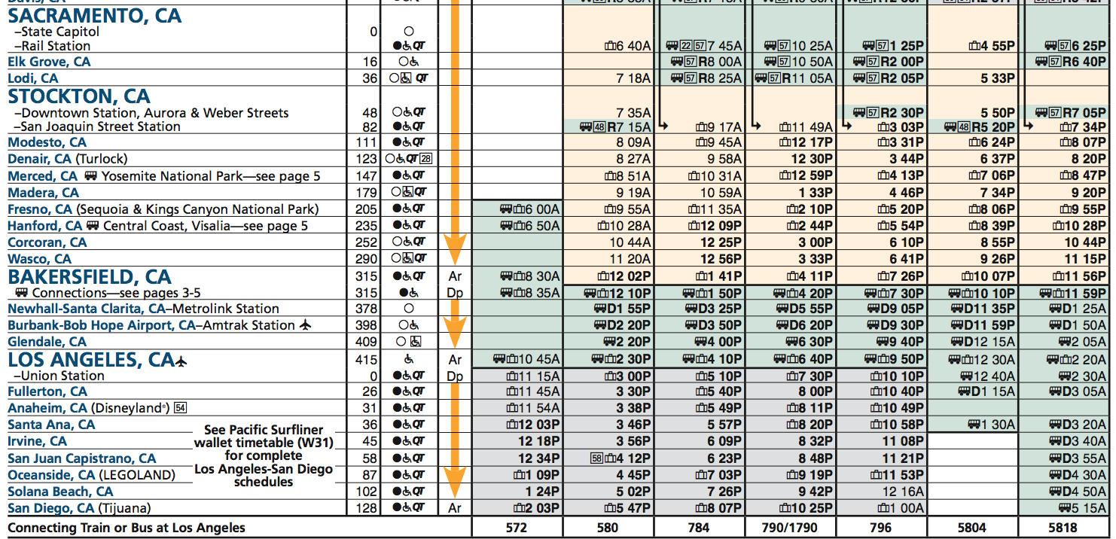

TO LOS ANGELES BY TRAIN: TRAINS FROM RENO AMTRAK STATION TO LOS ANGELES
To get from Reno to Los Angeles, get to Bakersfield. Purchase tickets all the way to Los Angeles, but know that you’ll stop in Sacramento and Bakersfield along the way. Tickets should cost $80. The schedule is above.

TO SAN DIEGO BY TRAIN: TRAINS FROM RENO AMTRAK STATION TO SAN DIEGO
To get from Reno to San Diego, get to Los Angeles. Purchase tickets all the way to San Diego, but know that you’ll stop in Sacramento, Bakersfield, and Los Angeles along the way. Tickets should cost $98. The schedule is above.
EMERGENCY SERVICES
These service providers can help you in the event of a problem:

SACRAMENTO:  For all services, dial 2-1-1 on any phone.  Emergency Shelters for men:  Union Gospel Mission  400 North Bannon Street, Sacramento, CA 95814  Ph. (916) 447-3268  Provides a seven 7-night stay for single men. Be there at the black metal gate by 5:30 p.m. for a first come/first serve basis. You can have 7 nights in, then stay out for three nights, and come back for 7 more days. Preference usually given to "first timers" or new people, so let the staff know if this is your first time.  Salvation Army  200 North B Street, Sacramento, CA 95814  Ph. (916) 442-0331 x0  Emergency shelter provided for single men or women only. You must be at their B street lobby at 1:00 p.m. for placement onto the waiting list. Offers a 30 to 60 day shelter assisting in employment and housing independence.  Adult Shelter VOA  1400 North A Street, Building B, Sacramento, CA 95814  Ph. (916) 448-5507  You must show up the first time to have your name placed on the waiting list. Check in each day 9:00 a.m. to 12:00 p.m. - Intake is at 1:00 p.m. Call in each day for check-in after your name is on the list. When your name is close to the top, then show up or if you call in the staff will tell you to show up if you may receive a bed space. | LOS ANGELES: For all services, dial 2-1-1 on any phone.  Shelters:  Year Round Emergency Shelter  (800) 548-6047,  TTY: (800) 660-4026
BAKERSFIELD: For all services, dial 2-1-1 on any phone.

Shelter and Food:
Bakersfield Homeless Center
1600 East Truxtun Avenue, Bakersfield, CA
(661) 322-9199
OAKLAND  Food:  Alameda County Community Food Bank  Call 510-635-3663 to get registered to pick up food.  Their address is 7900 Edgewater Drive Oakland, CA 94621  Shelters: Dial 2-1-1 on any phone, and someone will direct you to a shelter. Also try:  City Team  722 Washington St., Oakland, CA.  510.452.3758 and wait to dial 26  Healthcare: Dial 9-1-1 if it is an emergency.  1411 E 31st St, Oakland, CA ‎  (510) 437-4800 ‎ | SAN DIEGO: For all services, dial 2-1-1 on any phone.
SAN FRANCISCO
Food: Glide serves over 1,000 meals daily.
Glide Memorial Church
330 Ellis St.
415-674-6000

Shelter: Dial 2-1-1 on any phone, and someone will direct you to a shelter.

Healthcare: Dial 9-1-1 if it is an emergency.
San Francisco General Hospital
1001 Portrero Ave.
San Francisco, CA 94110
415-206-8000

