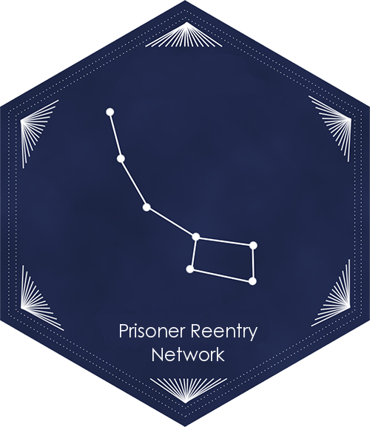

Transportation from
Sierra Conservation Center - Jamestown

Directions to the Bay Area, Central California (Sacramento to Bakersfield), and Southern California (LA and San Diego)

Updated: 10.10.16
CONTENTS:
- LEAVING PRISON  - MODESTO AMTRAK  - Purchasing Tickets at a Greyhound Station  - PURCHASING TICKETS AT AMTRAK STATIONS  - TRAINS TO BAY AREA | - TRAINS TO SACRAMENTO  - TRAINS TO BAKERSFIELD, LOS ANGELES, SAN DIEGO  - Getting Around the Bay Area Using BART  - Traveling around LA using Metrolink  - EMERGENCY SERVICES

Getting home from prison can be difficult and expensive, and you may have no more than $200 to pay for the return trip. This guide is intended to provide information on transportation options from prison.

LEAVING PRISON:
On the day of your release, you will be taken to Receiving and Release, where you will be provided clothing, identification, and gate money.

Clothing: The prison will provide you clothes for your release. There are some clothes that have been donated, and you also may purchase clothes from PIA using your gate money.

If someone has sent dressouts, they will be waiting for you at Receiving and Release. An individual must send the items thirty days prior to your release, write “dressouts” as well as the person they are being delivered to.
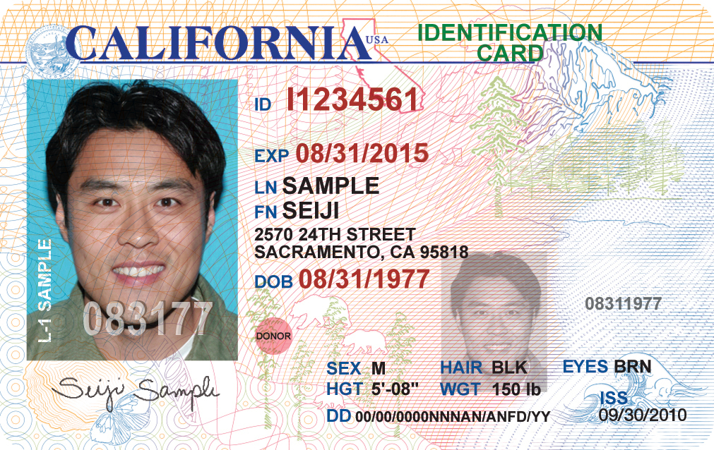
Identification: You may keep your CDCR-issued identification, and this will likely be the only identification available. However, recent legislation has required CDCR and DMV to supply individuals leaving prison with identification. Starting January 1st, 2015, AB 2308 requires the California Department of Corrections and Rehabilitation and the Department of Motor Vehicles to ensure that inmates released from state prisons have valid identification cards (pictured right).

If you are leaving prison, and you meet all the following requirements:
- Previously held a CA driver’s license or ID card.
- Have a usable photo on file with the DMV that is not more than 10 years old.
- No outstanding fees due for a prior CA identification card.
- DMV verified your name, date of birth, social security number, and legal presence in the US.
Then, you should get an identification card. Prior to release, speak with your counselor about getting your CA ID. Identification is in important to get public benefits, housing, and other important necessities.
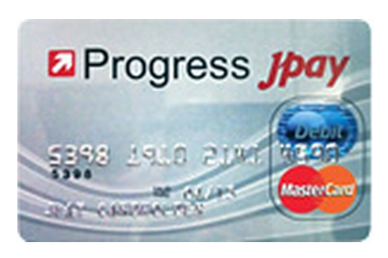
Gate Money: Deuel Vocational Institution started issuing debit cards as gate money (pictured left) instead of cash. This debit card should have your $200 gate money, in addition to the money in your trust account.

Asking for help: “My advice would be to ask for help. I asked for directions from anybody I could once I got to San Francisco. I actually asked directions from three police officers. I left with another guy, and he was freaking when I approached the police. I told him, ‘Relax we’re not doing anything – we’re free.’” – Mark Self, released from Solano 2015.

Electronic Tellers: Americans now purchase many items from electronic tellers. “The weirdest experience I had was going to a store and there were no tellers – just go in in and check yourself out. That was crazy,” recalled Daron Jones, who served thirty years and was released in 2015. Electronic tellers are discussed extensively in this packet.

Modesto Amtrak Station: If you do not have someone scheduled to pick you up, you will likely be taken to the Modesto Amtrak Station (100 Held Dr.). It looks like this:
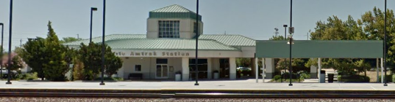

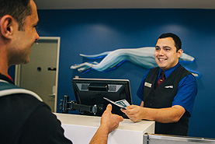
PURCHASING GREYHOUND TICKETS FROM AN AGENT
At the Greyhound station there will likely be a uniformed ticket agent at the counter (see right). They will help you buy a ticket to wherever you are going. You may have to get off the bus and onto other buses on your trip. If possible make sure you buy all tickets needed for your Greyhound trip at your first Greyhound station, rather than purchasing separate tickets at each stop, however do what the ticket agent instructs.

PURCHASING TICKETS USING THE GREYHOUND KIOSK MACHINE
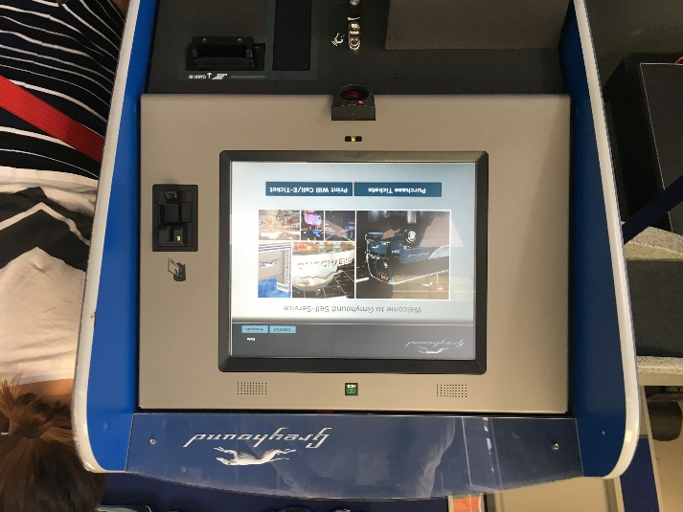
If the Bus/Greyhound station you are at does not have a ticket office/agent, you can purchase bus and train tickets at the Greyhound kiosk machine as shown to the left. You may have to get off the bus and onto other buses on your trip. If possible make sure you buy all tickets needed for your Greyhound trip at your first Greyhound station, rather than purchasing separate tickets at each station you stop at.

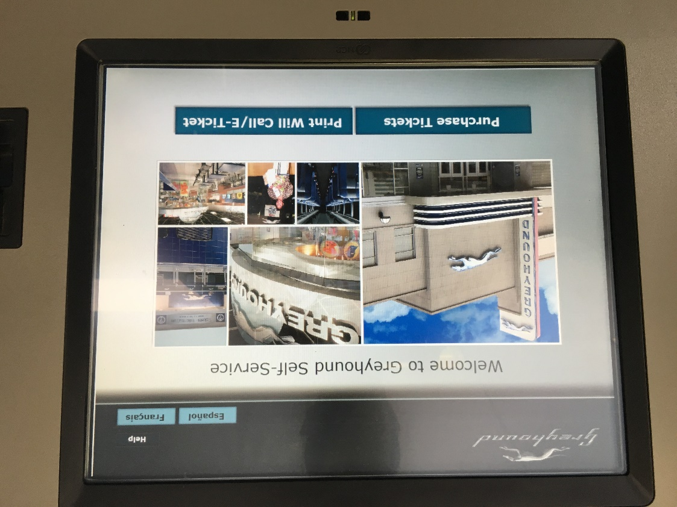
The Greyhound kiosk machine uses a touch screen. To purchase tickets using the Greyhound kiosk machine, follow these instructions:

Press the Purchase Tickets button

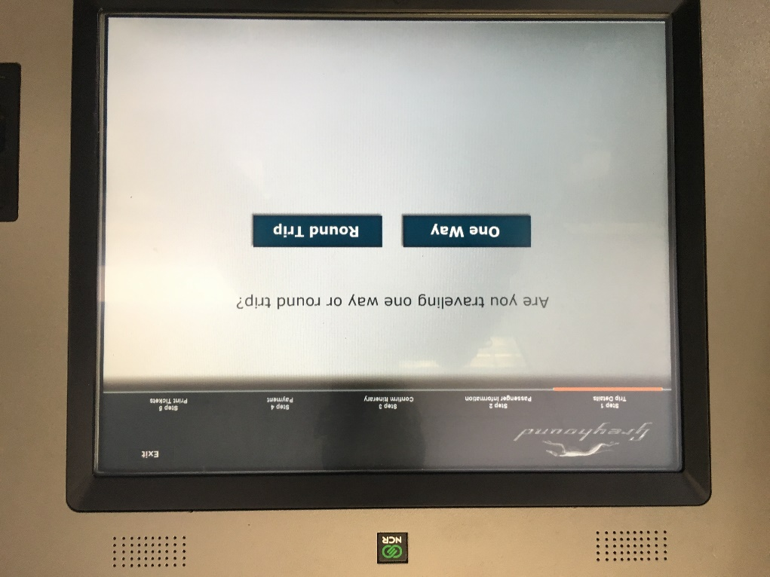

Press the One Way button.

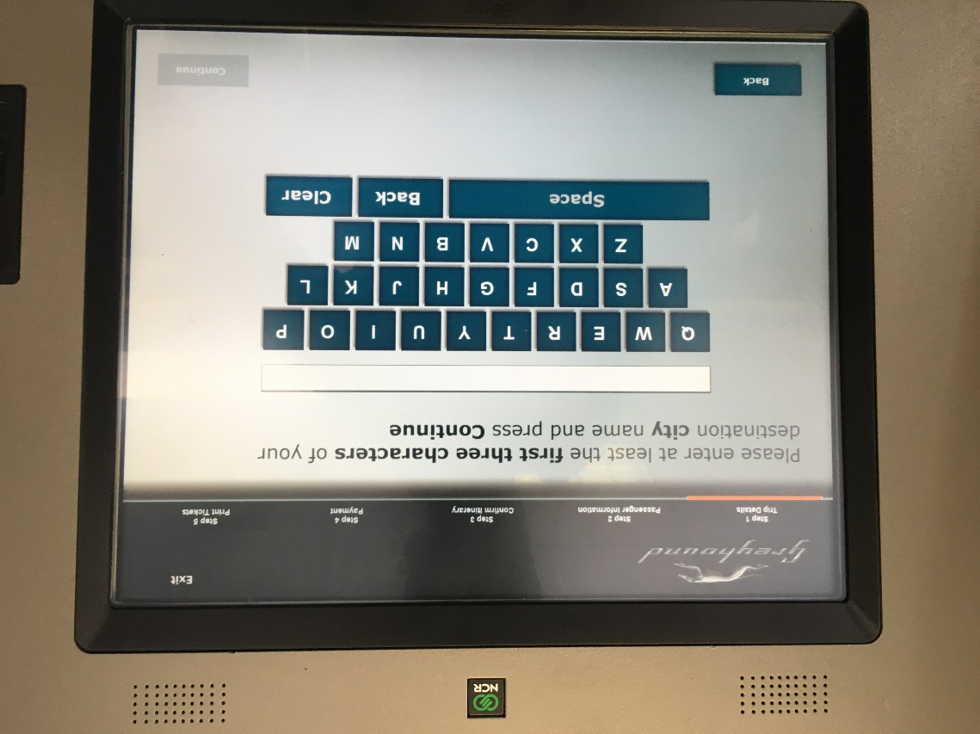

Press the first three letters of your destination, the press the Continue button in the bottom right corner.

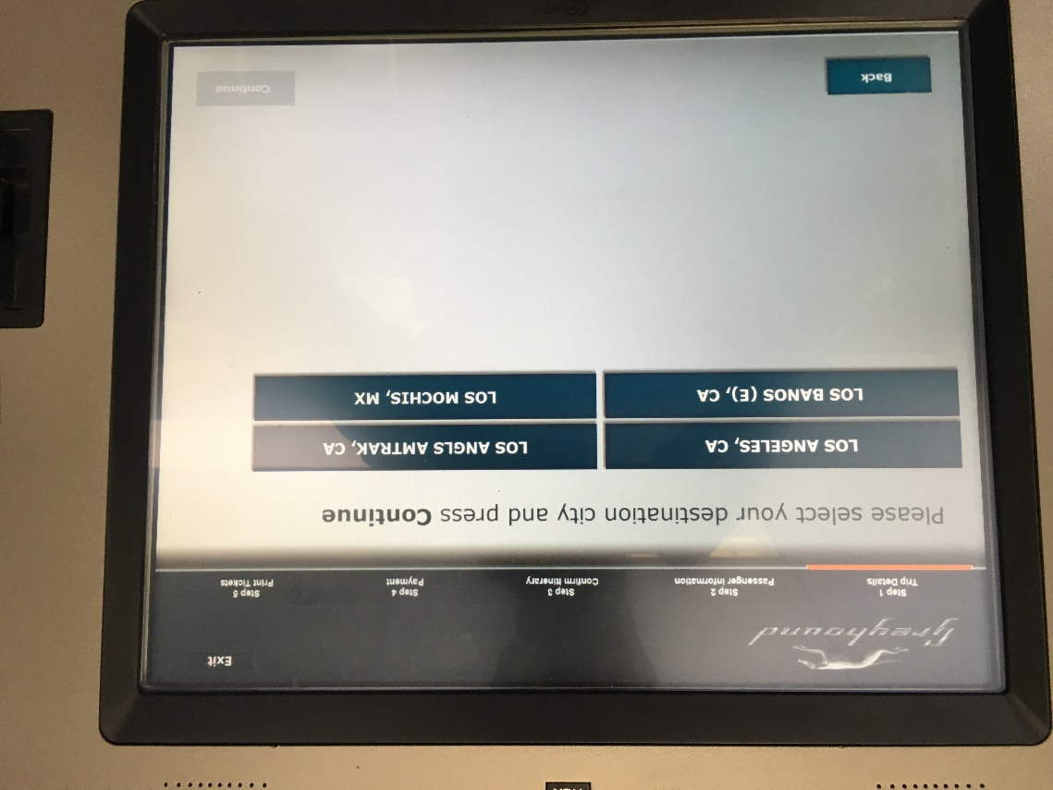

Press your destination on the screen and then press the Continue button in the bottom right corner.

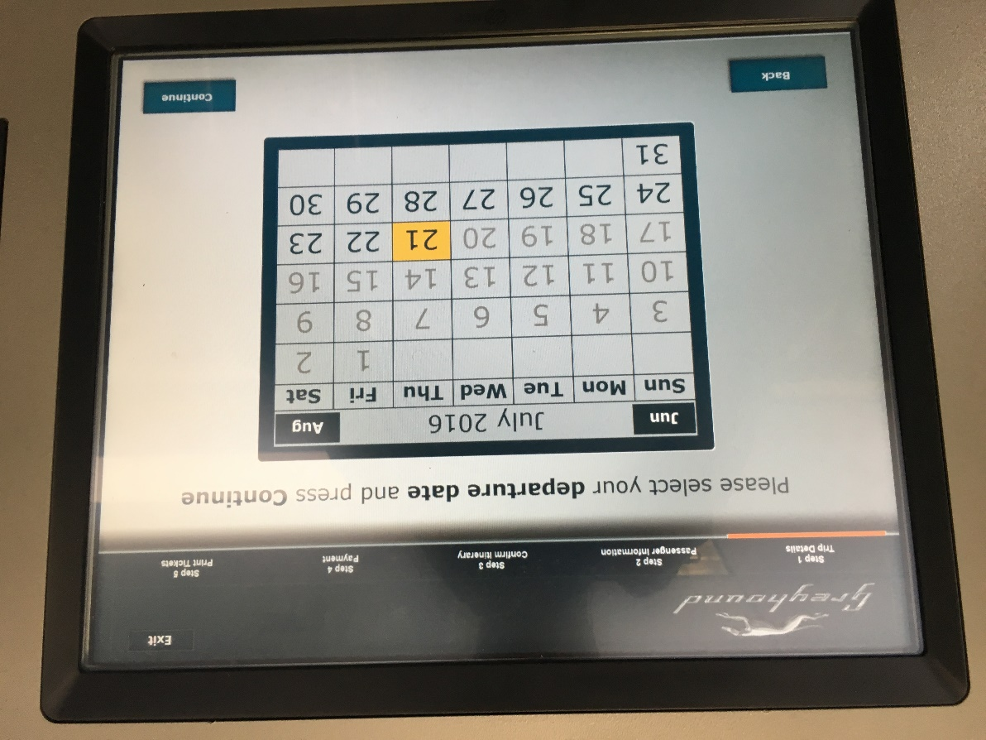

Press your departure date (probably today’s date) and then press the Continue button.

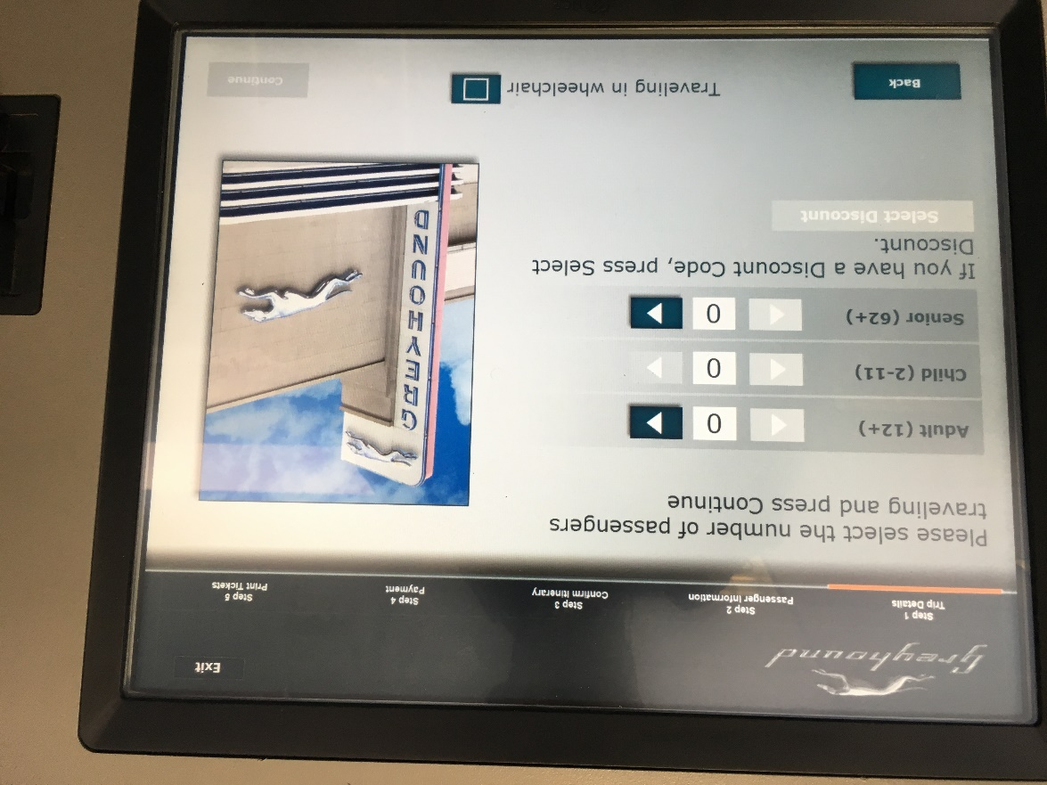
Press the > (arrow) button next to the type of tick you would like to buy. Then press the Continue button.

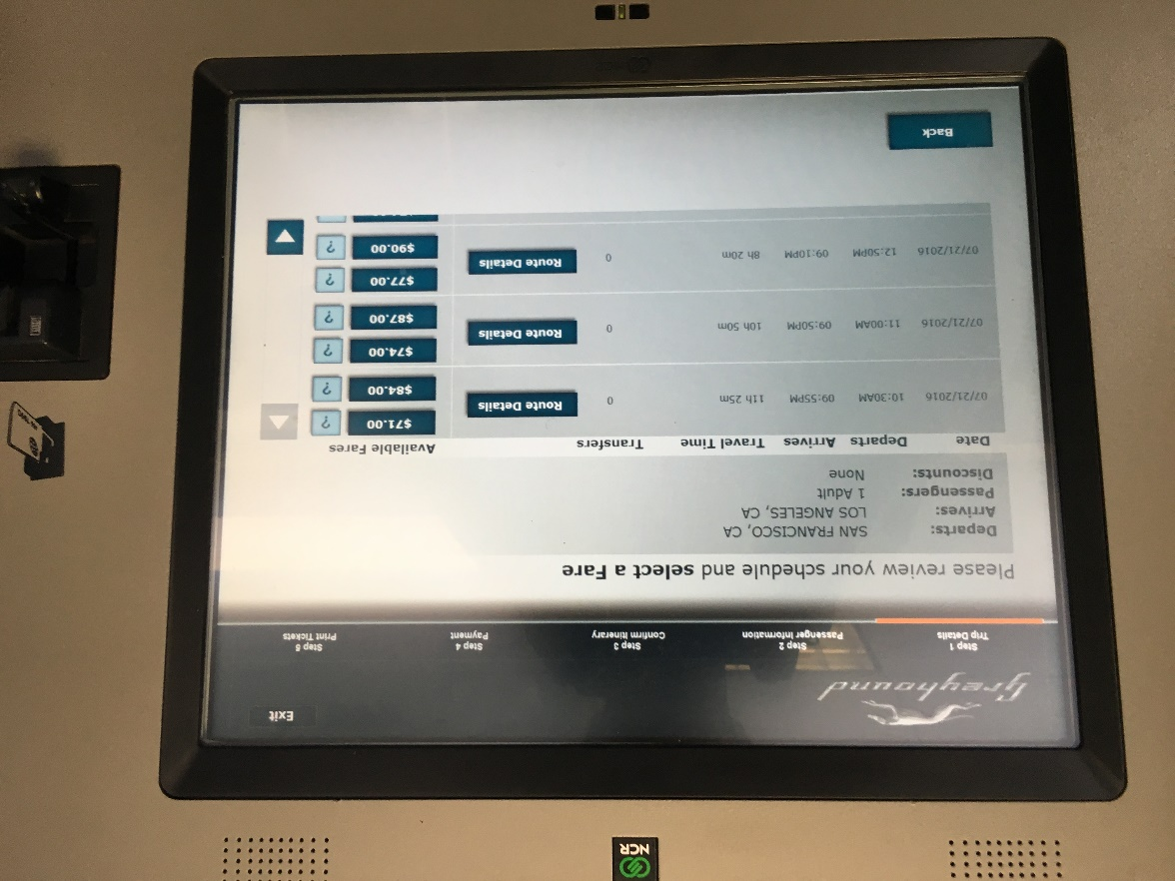

Press the least expensive price of the trip you would like to take. When the machine asks “Would you like to accept this fare?” press Accept.

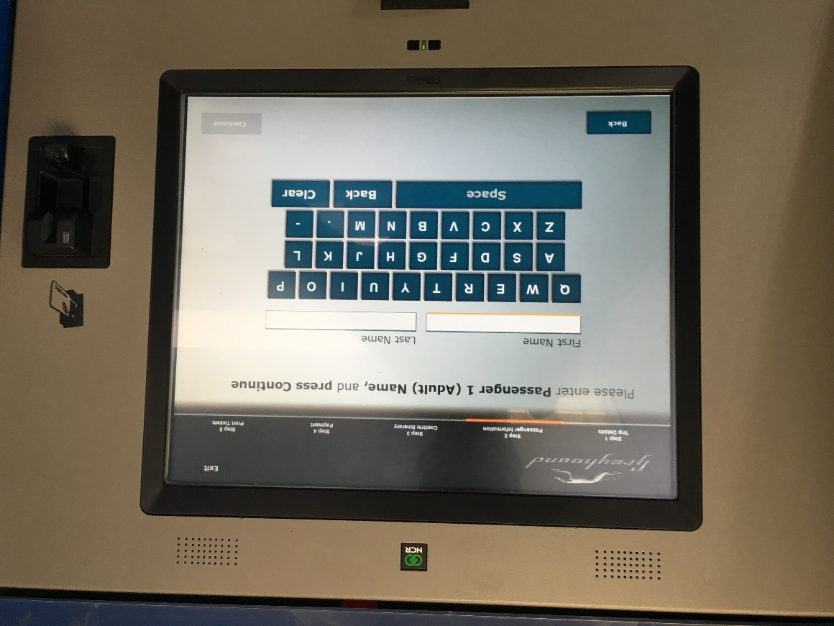
Type your first and last name into the machine. Then press the Continue button. It will then ask you to “Review your Itinerary and Charges.” Make sure everything is as you want it to be then press the Continue button. It will then take you to “Terms and Conditions.” Press the Accept button in the bottom right corner.

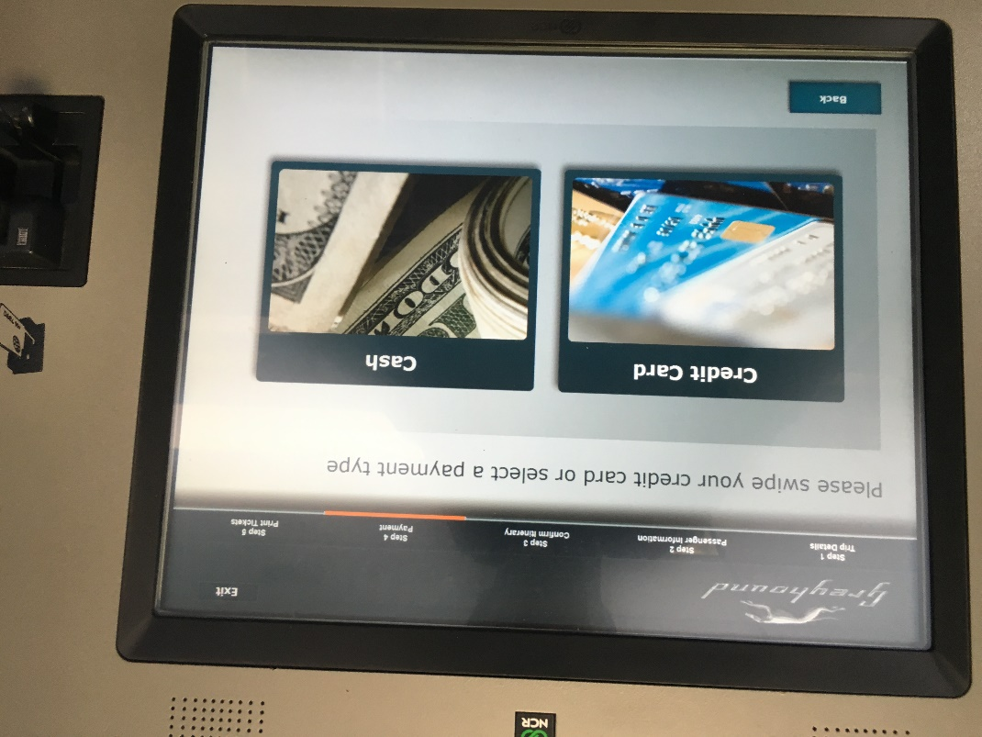
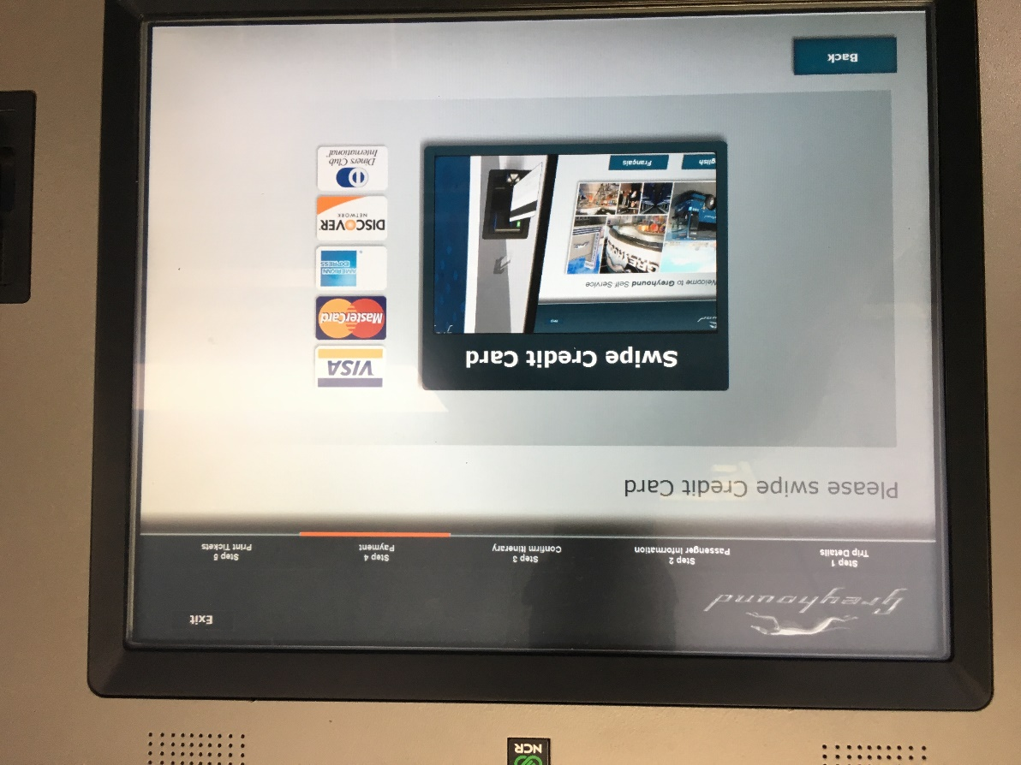
Press the way you would like to pay. This likely with “credit card” unless you have cash. You can use the card CDCR provided upon release.
Swipe your card in the slot on the right of the machine the way shown in the picture. Your ticket should print and be delivered below the screen.

Congratulations! You’re on your way.
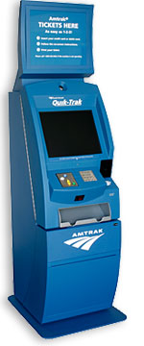
PURCHASING TICKETS AT AN AMTRAK STATION USING A TICKET MACHINE
The Bus/Amtrak station does not have a ticket office. Instead, there is an electronic kiosk where you can purchase bus and train tickets (pictured left). Make sure you buy a ticket all the way to your final destination, rather than purchasing separate tickets for each leg of the journey.

The Quik-Trak machine uses a touch screen. To purchase tickets using the Quick-Trak Machine, follow these instructions:
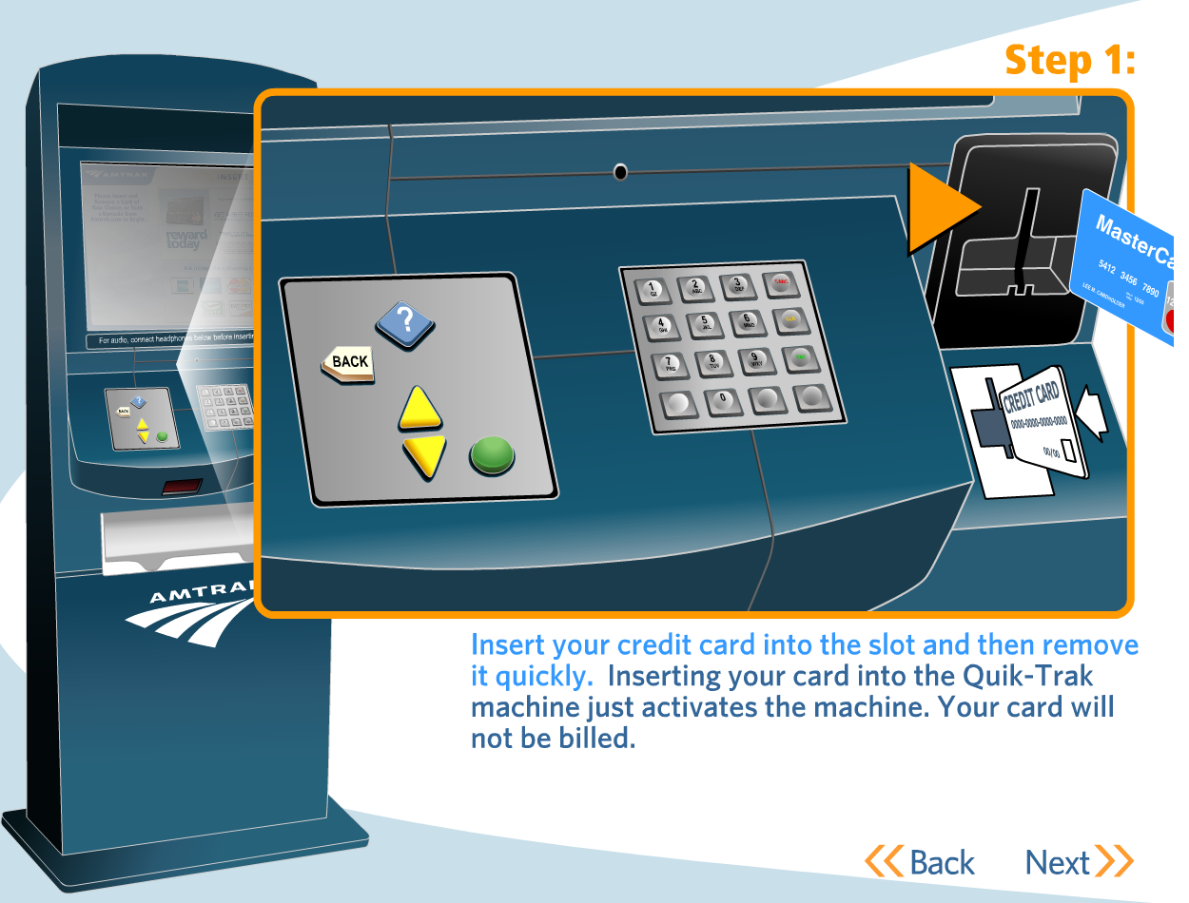

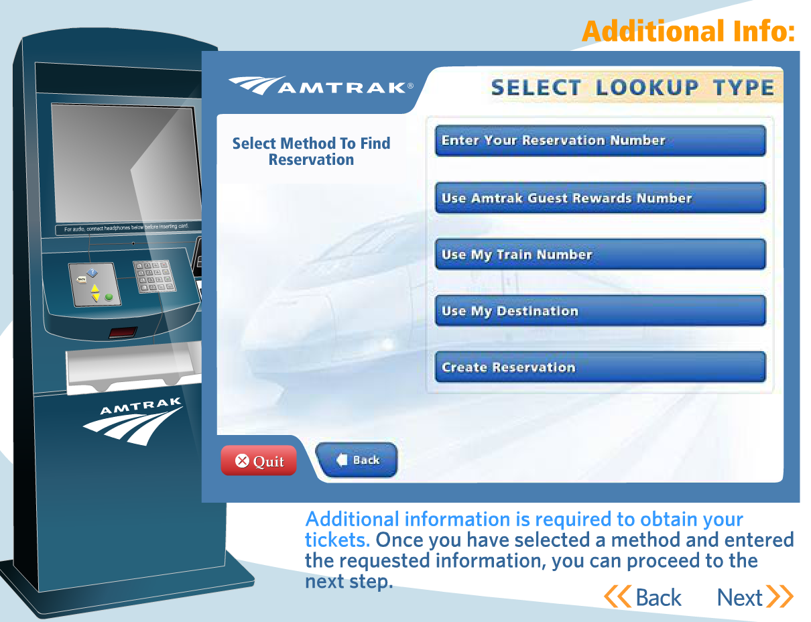
Step 2: Touch “Create Reservation” and select the location where you would like to go, and when.

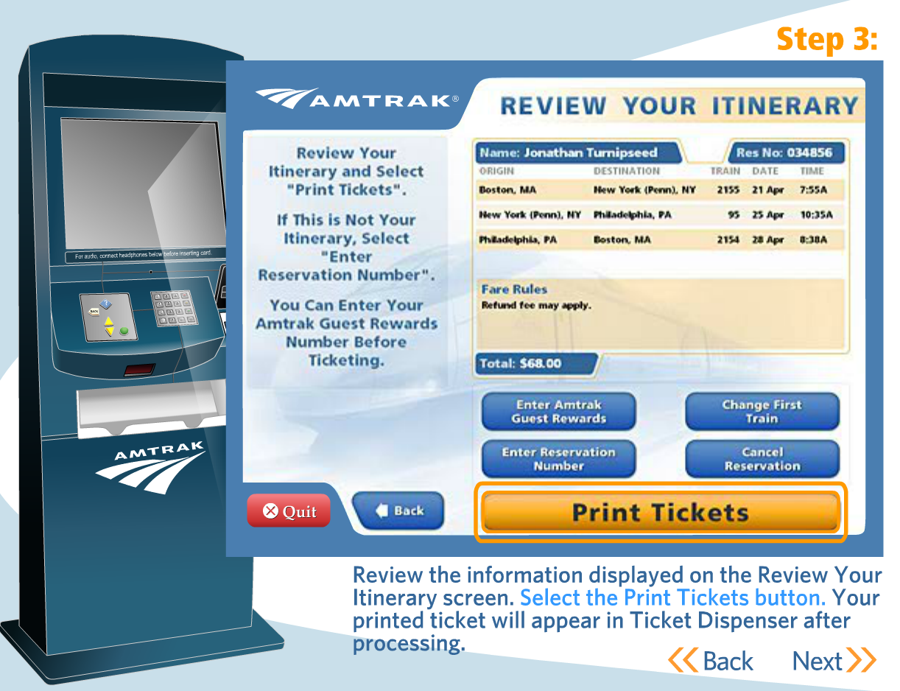

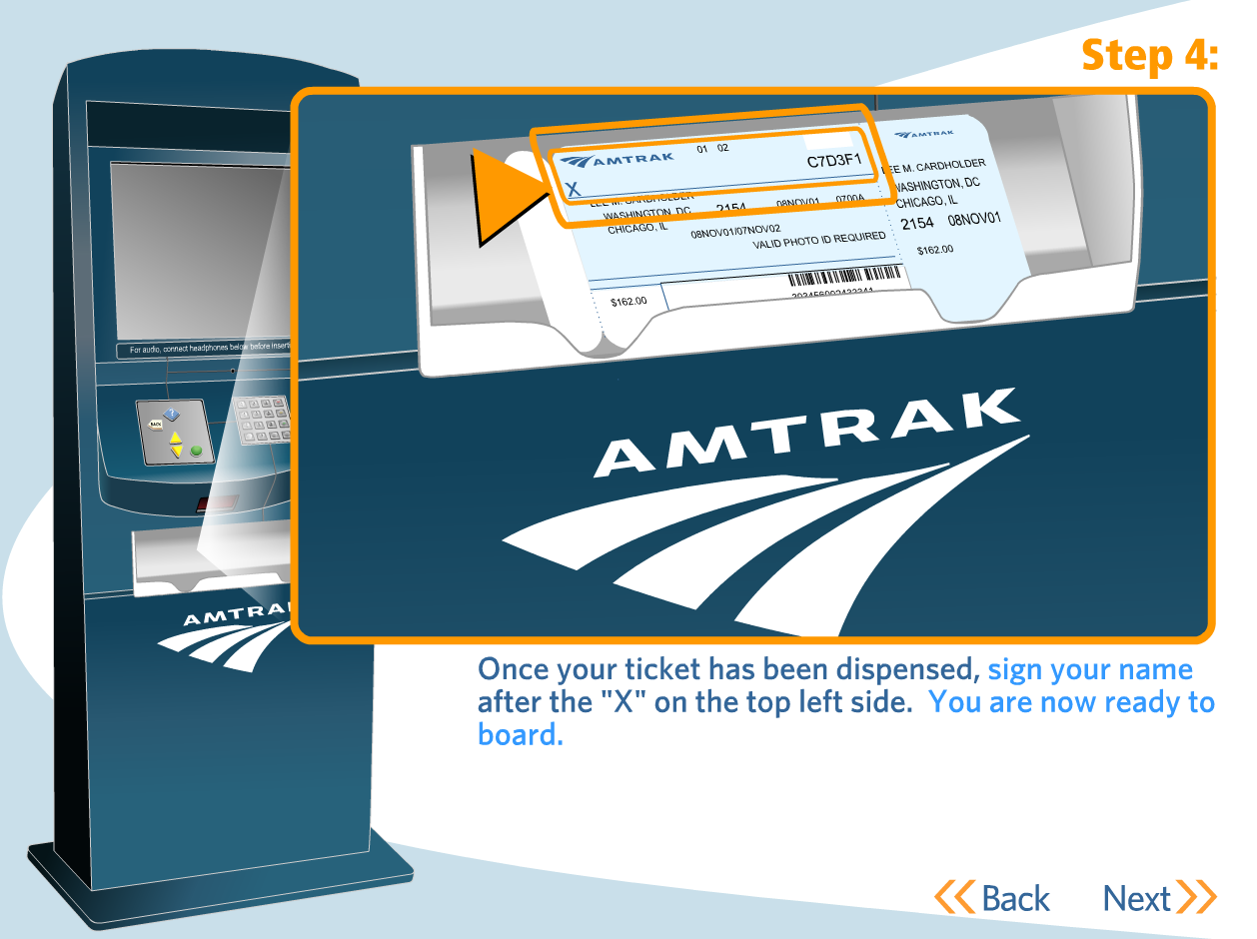

UNDERSTANDING YOUR AMTRAK TICKET AND TRIP
Your Amtrak ticket should look like one of the following shown below. They list your name, departure and arrival location, departure and arrival time. To find the boarding gate where your train is leaving ask an Amtrak employee or look for a monitor that lists it. These monitors will usually list the boarding gate 15 minutes before the departure time of the train. Make sure to get on your train as soon as possible - some trains will not let you on if you don’t board 10 minutes before the departure time. You may have to get on multiple trains to get to your destination. For part of your Amtrak trip you may have to take a Thruway Bus. If you cannot find something make sure to talk to people. Try to find someone who works at Amtrak, but you can always ask for help from a stranger.
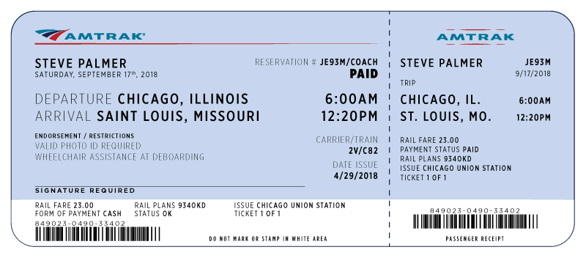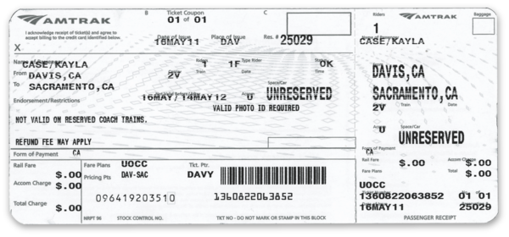

TRAINS FROM MODESTO TO SACRAMENTO AND THE BAY AREA:
To get from Stockton to the Bay Area, Bakersfield, or anywhere in California, the most efficient way is through the San Joaquin train, which leaves from the Modesto Amtrak. To get to the Bay Area, take the NORTHBOUND San Joaquin Train. It leaves from the Stockton Amtrak station at 7:53am, 11:43am, 2:06pm, and 5:00pm. and and should cost about $40. Here is the schedule:

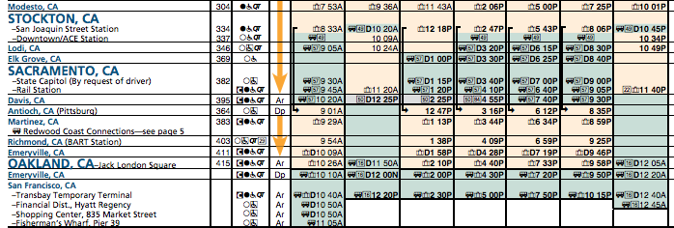
For information on travel around the Bay Area, go to the section on BART.

To get to Sacramento, you may have to transfer to a bus. Buy tickets all the way to your desination, regardless of whether the schedule indicates an exchange will be necessary.

TRAINS FROM STOCKTON TO BAKERSFIELD, LOS ANGELES, AND SAN DIEGO:
To get from Stockton to Bakersfield, Los Angeles and San Diego, the most efficient way is through the San Jaquin train, which leaves from the Modesto Amtrak. Take the SOUTHBOUND San Joaquin Train. It leaves the Modesto Amtrak Station at 8:04am, 9:53am, 12:07pm, and 2:51pm. You then transfer to a bus, which will take you to Los Angeles. The schedule is here:

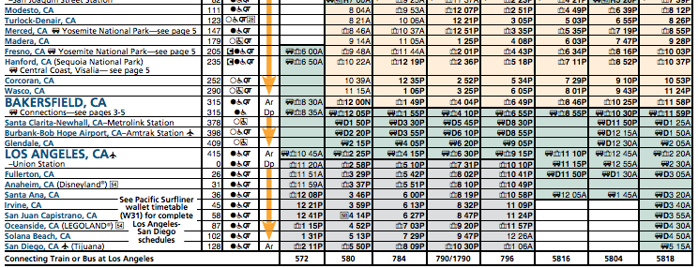

In Los Angeles, you can take a train, the Pacific Surfliner, to San Diego. The schedule is here:

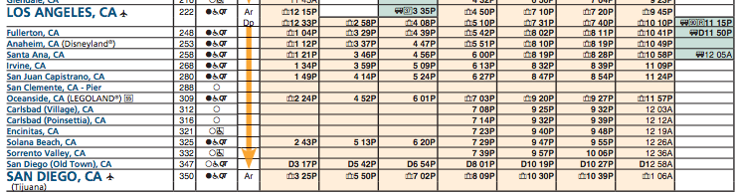
TRAVEL IN THE BAY AREA USING BART: Once you are in Richmond, you can transfer to Bart. BART stands for Bay Area Rapid Transit. BART operates five routes on 104 miles (167 km) of line, with 44 stations in four counties. With an average of 373,945 weekday passengers, 176,616 Saturday passengers, and 119,247 Sunday passengers in January 2013. The BART logo looks like this:
BART CARD: This a BART card (pictured right). Insert it into the turnstile (pictured below) on both entry and exit.

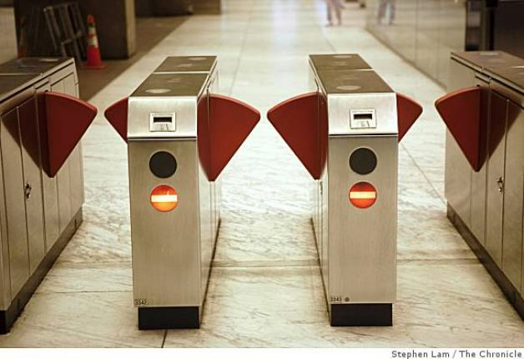

Once you exit, the funds are removed based on the length of your travel. You can know how much money remains on your card by looking next to the arrow, where the remaining amount is printed.

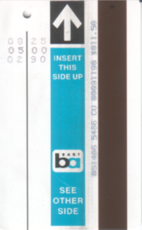

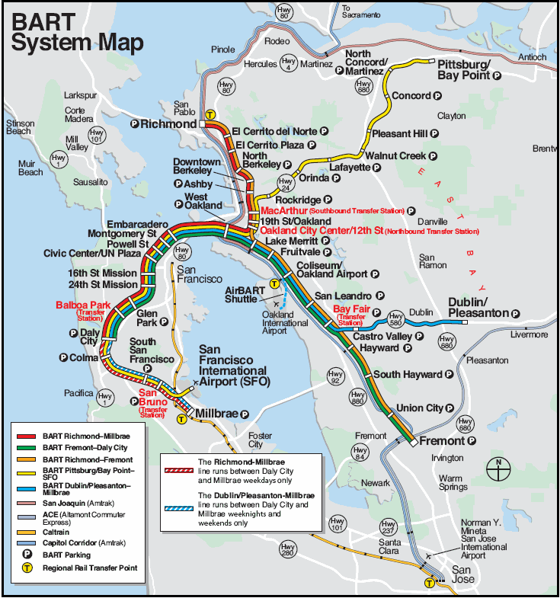
The BART system is complicated, but you can get to most destinations in the Bay Area.
TRAVEL AROUND LOS ANGELES AREA USING METROLINK:

Once you make it to Los Angeles, you can get around the area using MetroLink:

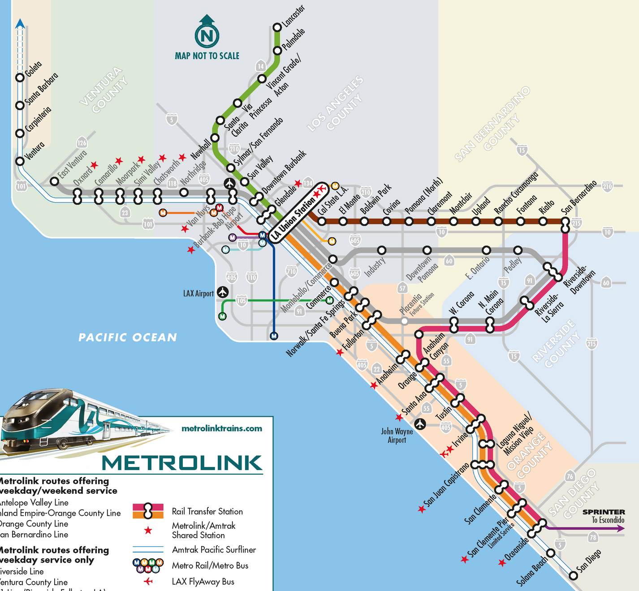

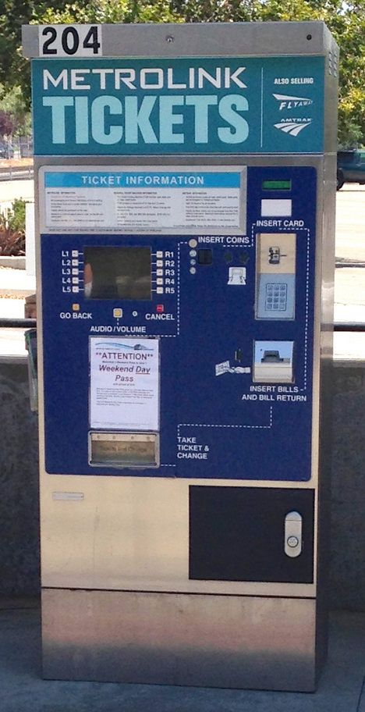
Purchasing Metrolink Tickets with Ticketing Machine:
Metrolink tickets are not sold onboard the train, and must be purchased prior to barding the train. Ticket vending machines (pictured right) are located on Metrolink train platforms. To purchase a ticket, follow these instructions:
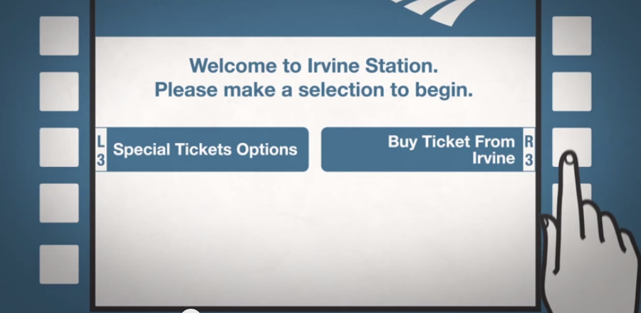
Step 1: Using the buttons surrounding this screen, select “Buy Ticket From Los Angeles”

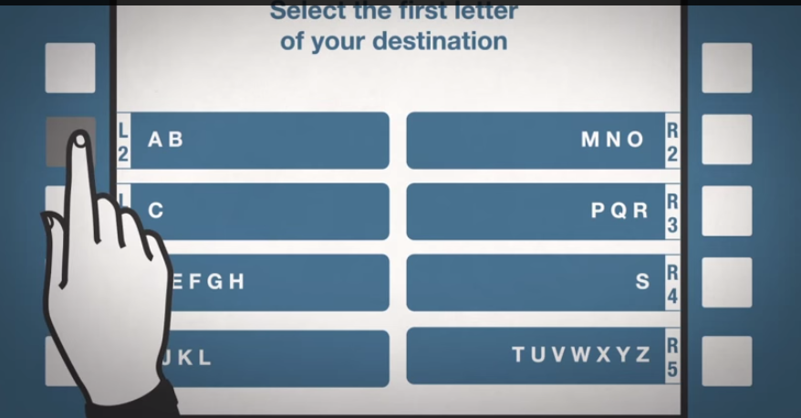

Step 2: Select the first letter of your destination.

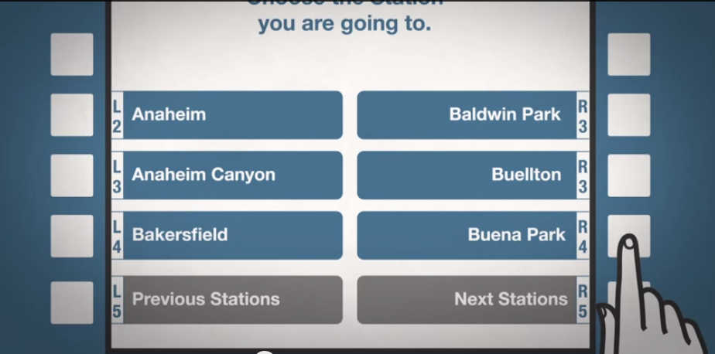
Step 3: Select your destination.
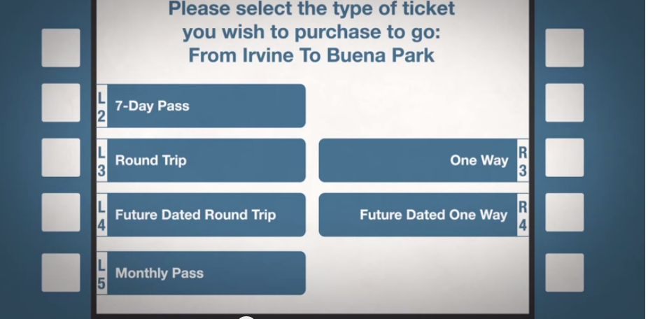

Step 4: Select One Way trip.

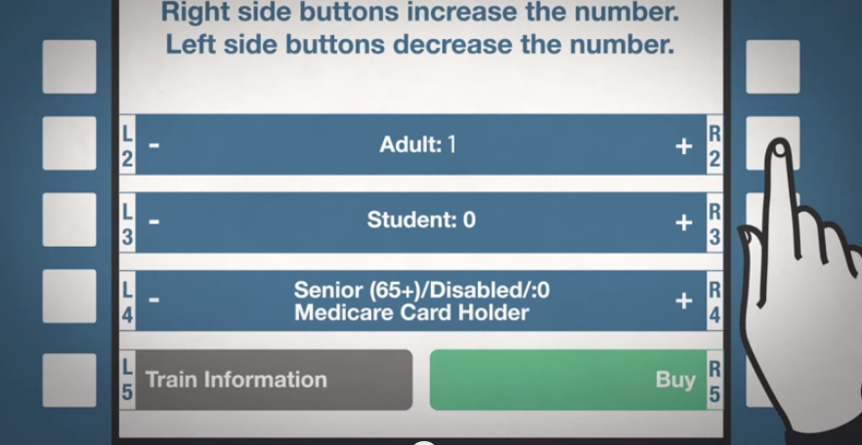
Step 5: Select the ticket type. If you are over 65 or disabled, be sure to get a reduced fee ticket.

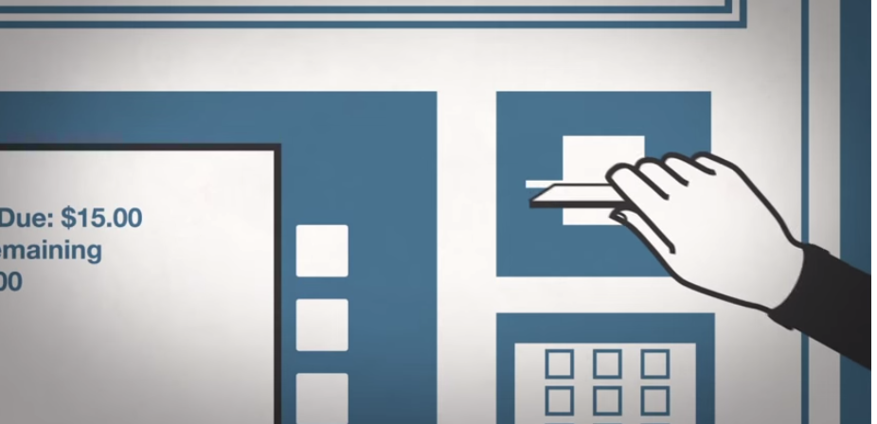
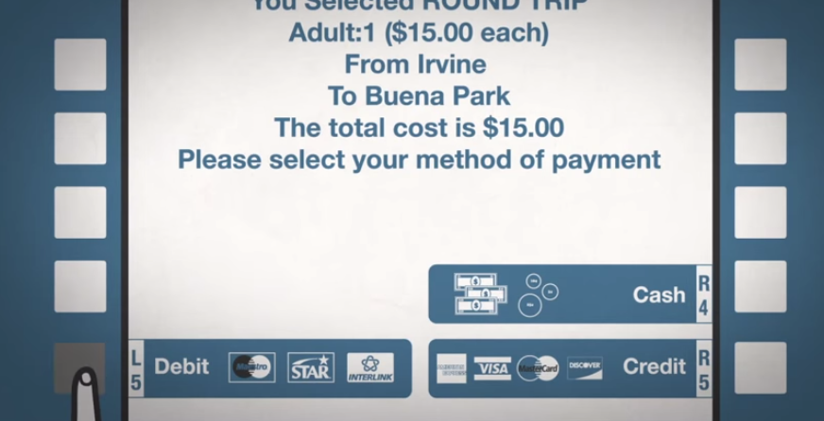
Step 6: Select “Credit” as your payment type and put your gate money card into the machine.
EMERGENCY SERVICES
These service providers can help you in the event of a problem:

SACRAMENTO:  For all services, dial 2-1-1 on any phone.  Emergency Shelters for men:  Union Gospel Mission  400 North Bannon Street, Sacramento, CA 95814  Ph. (916) 447-3268  Provides a seven 7-night stay for single men. Be there at the black metal gate by 5:30 p.m. for a first come/first serve basis. You can have 7 nights in, then stay out for three nights, and come back for 7 more days. Preference usually given to "first timers" or new people, so let the staff know if this is your first time.  Salvation Army  200 North B Street, Sacramento, CA 95814  Ph. (916) 442-0331 x0  Emergency shelter provided for single men or women only. You must be at their B street lobby at 1:00 p.m. for placement onto the waiting list. Offers a 30 to 60 day shelter assisting in employment and housing independence.  Adult Shelter VOA  1400 North A Street, Building B, Sacramento, CA 95814  Ph. (916) 448-5507  You must show up the first time to have your name placed on the waiting list. Check in each day 9:00 a.m. to 12:00 p.m. - Intake is at 1:00 p.m. Call in each day for check-in after your name is on the list. When your name is close to the top, then show up or if you call in the staff will tell you to show up if you may receive a bed space. | OAKLAND  Food:  Alameda County Community Food Bank  Call 510-635-3663 to get registered to pick up food.  Their address is 7900 Edgewater Drive Oakland, CA 94621  Shelters: Dial 2-1-1 on any phone, and someone will direct you to a shelter. Also try:  City Team  722 Washington St., Oakland, CA.  510.452.3758 and wait to dial 26  Healthcare: Dial 9-1-1 if it is an emergency.  1411 E 31st St, Oakland, CA ‎  (510) 437-4800 ‎
SAN FRANCISCO
Food: Glide serves over 1,000 meals daily.
Glide Memorial Church
330 Ellis St.
415-674-6000

Shelter: Dial 2-1-1 on any phone, and someone will direct you to a shelter.

Healthcare: Dial 9-1-1 if it is an emergency.
San Francisco General Hospital
1001 Portrero Ave.
San Francisco, CA 94110
415-206-8000

LOS ANGELES: For all services, dial 2-1-1 on any phone.  Shelters:  Year Round Emergency Shelter  (800) 548-6047,  TTY: (800) 660-4026 | SAN DIEGO: For all services, dial 2-1-1 on any phone.
BAKERSFIELD: For all services, dial 2-1-1 on any phone.

Shelter and Food:
Bakersfield Homeless Center
1600 East Truxtun Avenue, Bakersfield, CA
(661) 322-9199

