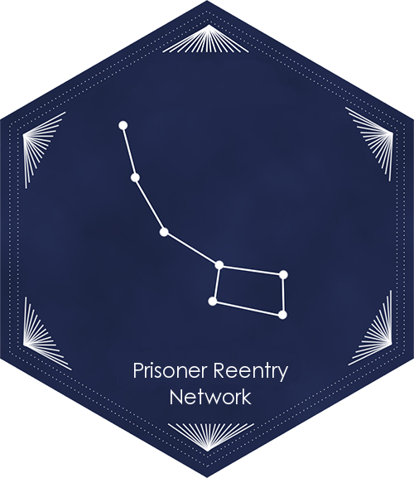
Transportation from CSP-Solano and CMF

Directions to the Bay Area, Sacramento, Bakersfield, Los Angles, San Diego, and Cities in Between

Updated: 8.10.16

CONTENTS:
- LEAVING Prison  - Suisun City/Fairfield Station  - PURCHASING TICKETS USING THE TOUCH SCREEN MACHINES  - TO BAY AREA  - Train Directions to Richmond, CA  - Bus Directions  - Travel in the Bay Area Using BART  - BART Map | - TO BAKERSFIELD  - TO SACRAMENTO  - TO LOS ANGELES  - TRAVEL AROUND LOS ANGELES USING METROLINK  - Map of Metrolink Connections  - Purchasing Metrolink Tickets with Ticketing Machine  - FROM LOS ANGELES TO SAN DIEGO  - EMERGENCY SERVICES

Getting from CSP-Solano to California can be difficult and expensive, and you may have no more than $200 to pay for the return home. This guide is intended to provide information on transportation options from CSP-Solano to the Bay Area, Sacramento, Bakersfield, Los Angles, San Diego, and cities in between.

LEAVING CSP-SOLANO and CMF:
Because CMF is a medical institution, only about one third of its prisoners are released to the bus station. According to the administration, they arrange transportation as far as necessary for individuals with a medical need. For those without medical needs prohibiting the use of public transportation, on the day of your release, you will be taken to Receiving and Release, where you will be provided clothing, identification, and gate money.

On the day of your release, and you will be taken to Receiving and Release, where you will be provided clothing, identification, and gate money.

Clothing: The prison will provide you clothes for your release. There are some clothes that have been donated, and you also may purchase clothes from PIA using your gate money.

If someone has sent dressouts, they will be waiting for you at Receiving and Release. An individual must send the items thirty days prior to your release, write “dressouts” as well as the person they are being delivered to.
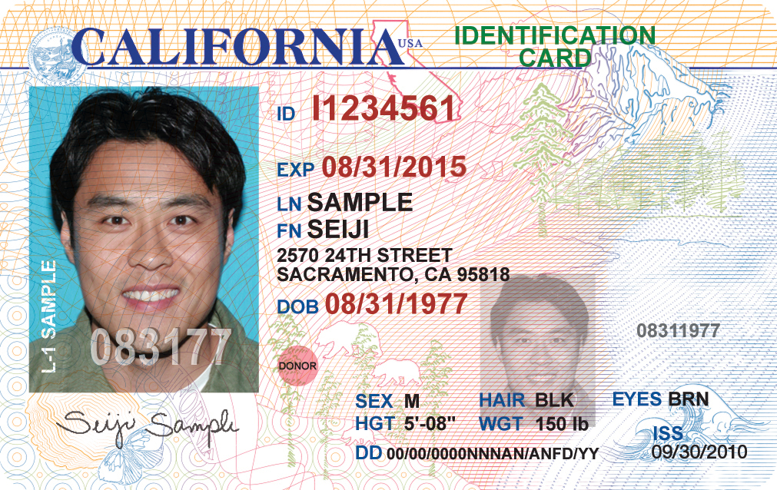
Identification: You may keep your CDCR-issued identification, and this will likely be the only identification available. However, recent legislation has required CDCR and DMV to supply individuals leaving prison with identification. Starting January 1st, 2015, AB 2308 requires the California Department of Corrections and Rehabilitation and the Department of Motor Vehicles to ensure that inmates released from state prisons have valid identification cards (pictured right).

If you are leaving prison, and you meet all the following requirements:
- Previously held a CA driver’s license or ID card.
- Have a usable photo on file with the DMV that is not more than 10 years old.
- No outstanding fees due for a prior CA identification card.
- DMV verified your name, date of birth, social security number, and legal presence in the US.
Then, you should get an identification card. Prior to release, speak with your counselor about getting your CA ID. Identification is in important to get public benefits, housing, and other important necessities.
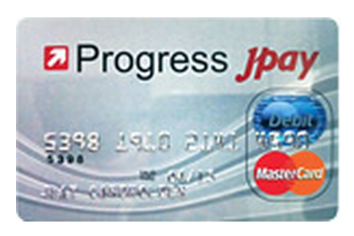
Gate Money: One month ago, CSP-Solano started issuing debit cards as gate money (pictured left). This debit card should have your $200 gate money, in addition to the money in your trust account.

Asking for help: “My advice would be to ask for help. I asked for directions from anybody I could once I got to San Francisco. I actually asked directions from three police officers. I left with another guy, and he was freaking when I approached the police. I told him, ‘Relax we’re not doing anything – we’re free.’” – Mark Self, released from Solano 2015.

Electronic Tellers: Americans now purchase many items from electronic tellers. “The weirdest experience I had was going to a store and there were no tellers – just go in in and check yourself out. That was crazy,” recalled Daron Jones, who served thirty years and was released in 2015. Electronic tellers are discussed extensively in this packet.

Suisun City Station: If you do not have someone scheduled to pick you up, you will be taken to Suisun City/ Fairfield Station, where you must get on a bus or train. It looks like this:
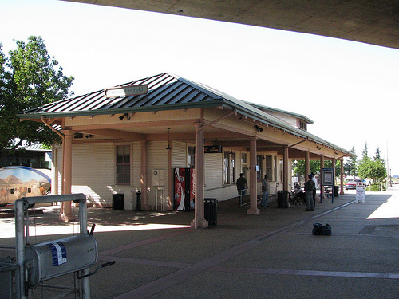
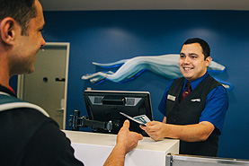
PURCHASING GREYHOUND TICKETS FROM AN AGENT
At the Greyhound station there will likely be a uniformed ticket agent at the counter (see right). They will help you buy a ticket to wherever you are going. You may have to get off the bus and onto other buses on your trip. If possible make sure you buy all tickets needed for your Greyhound trip at your first Greyhound station, rather than purchasing separate tickets at each stop, however do what the ticket agent instructs.

PURCHASING TICKETS USING THE GREYHOUND KIOSK MACHINE
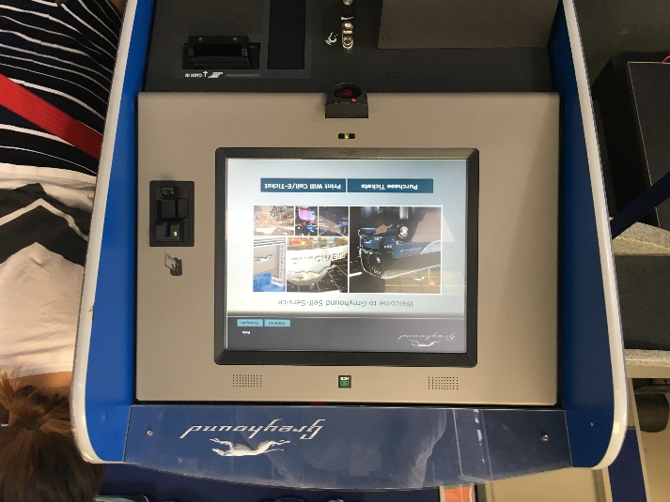
If the Bus/Greyhound station you are at does not have a ticket office/agent, you can purchase bus and train tickets at the Greyhound kiosk machine as shown to the left. You may have to get off the bus and onto other buses on your trip. If possible make sure you buy all tickets needed for your Greyhound trip at your first Greyhound station, rather than purchasing separate tickets at each station you stop at.

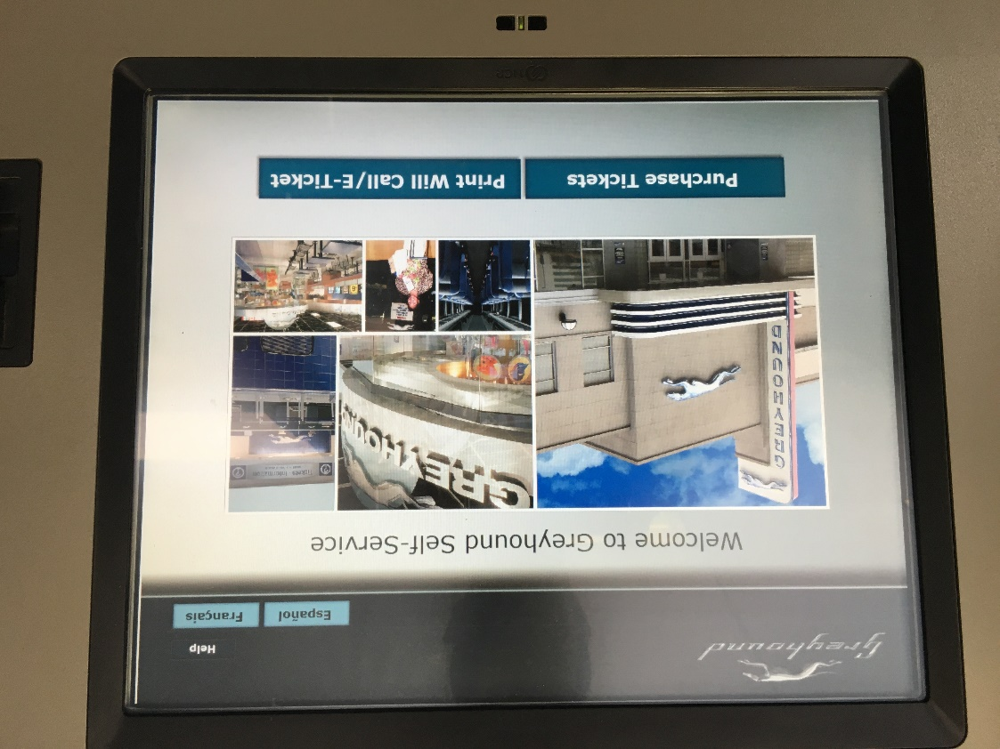
The Greyhound kiosk machine uses a touch screen. To purchase tickets using the Greyhound kiosk machine, follow these instructions:

Press the Purchase Tickets button

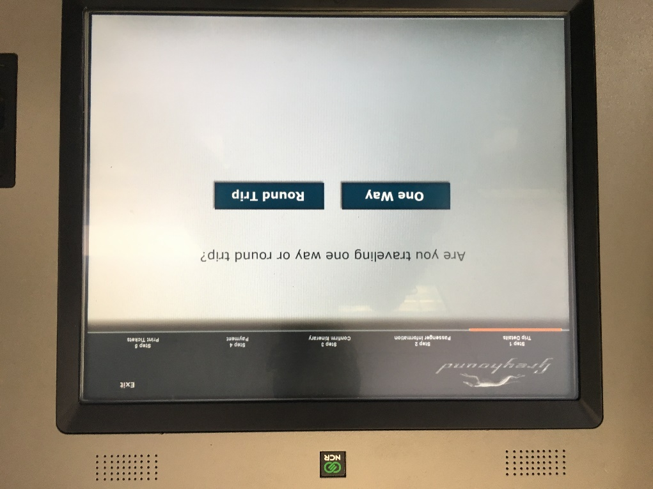

Press the One Way button.

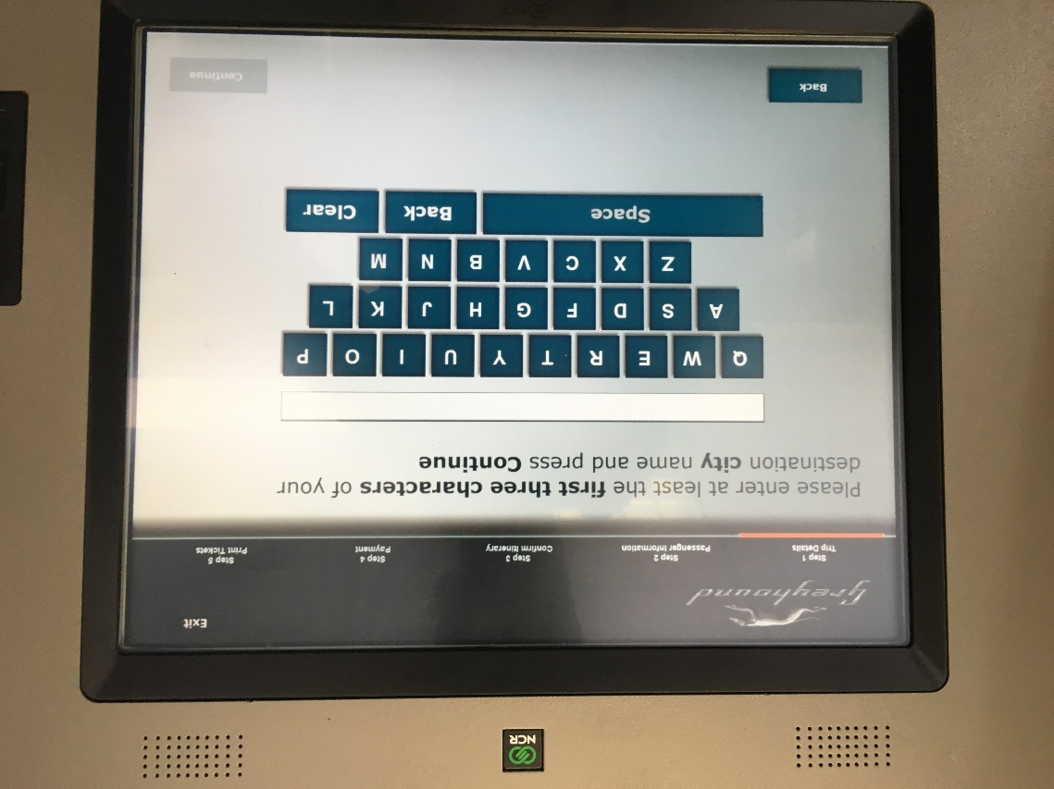

Press the first three letters of your destination, the press the Continue button in the bottom right corner.

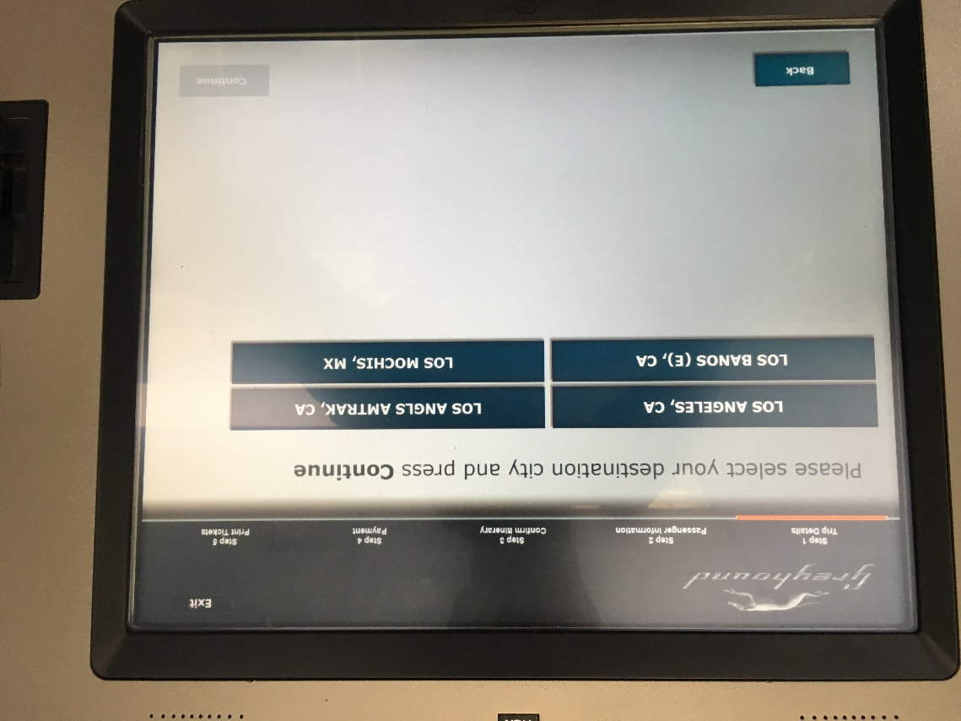

Press your destination on the screen and then press the Continue button in the bottom right corner.

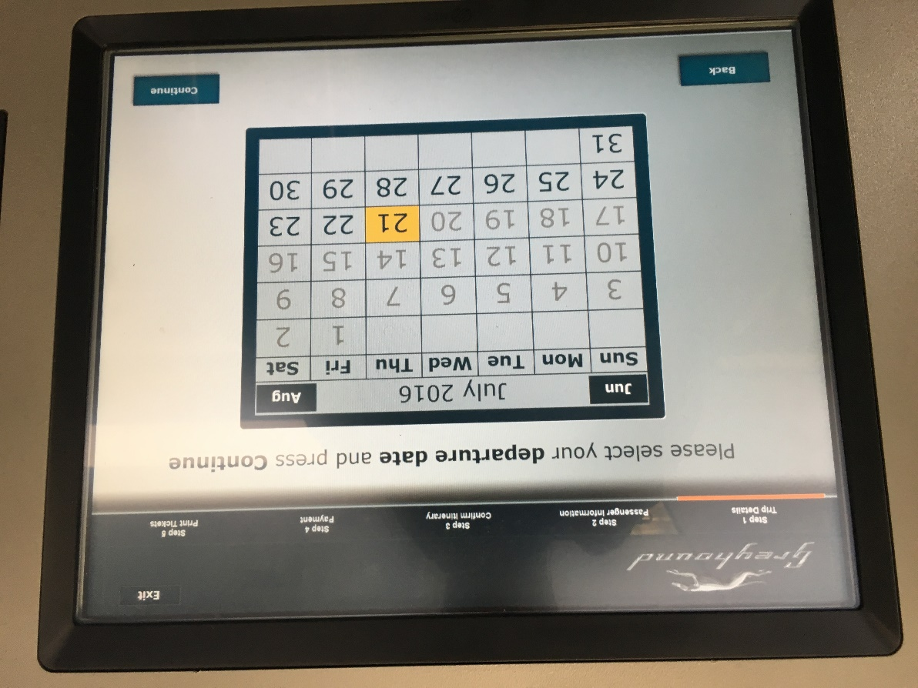

Press your departure date (probably today’s date) and then press the Continue button.

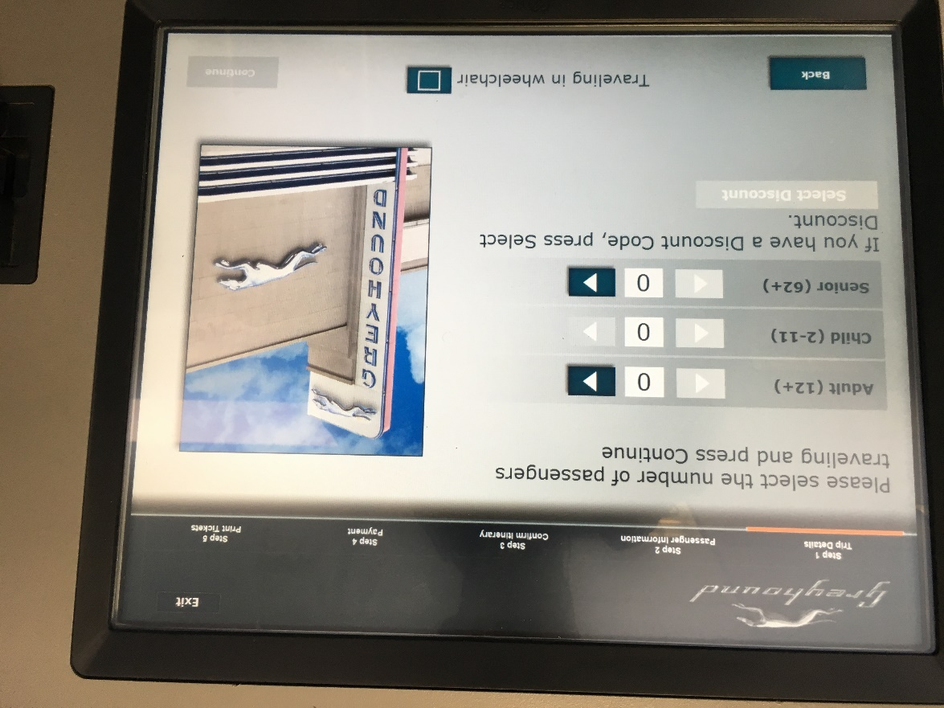
Press the > (arrow) button next to the type of tick you would like to buy. Then press the Continue button.

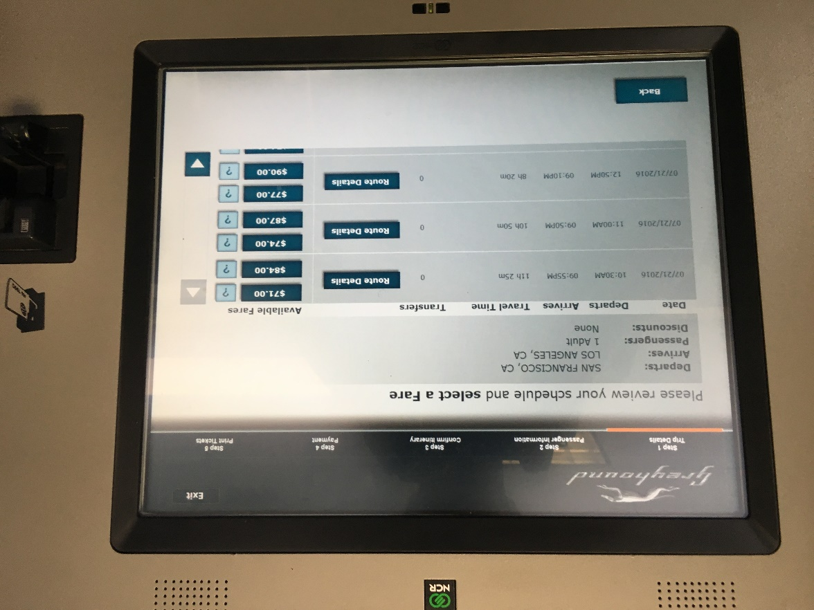

Press the least expensive price of the trip you would like to take. When the machine asks “Would you like to accept this fare?” press Accept.

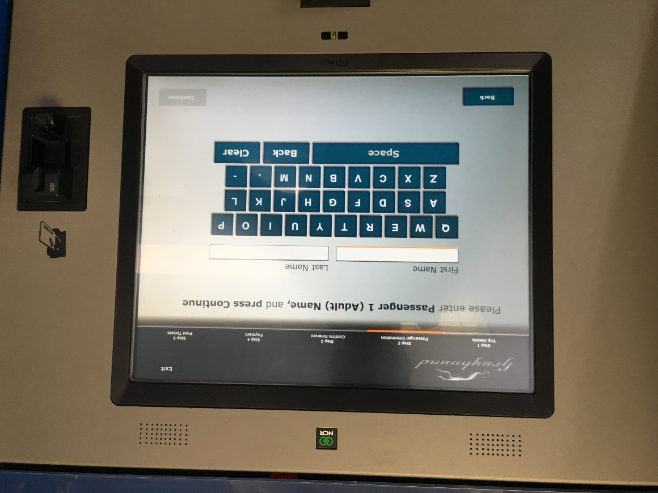
Type your first and last name into the machine. Then press the Continue button. It will then ask you to “Review your Itinerary and Charges.” Make sure everything is as you want it to be then press the Continue button. It will then take you to “Terms and Conditions.” Press the Accept button in the bottom right corner.

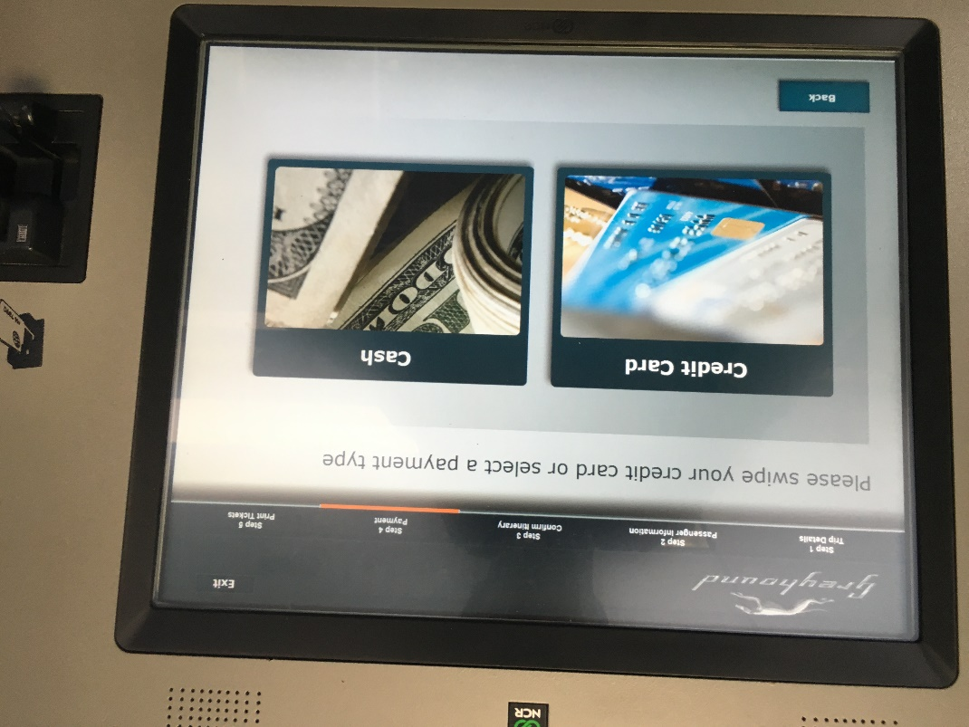
Swipe your card in the slot on the right of the machine the way shown in the picture. Your ticket should print and be delivered below the screen.

Congratulations! You’re on your way.
Press the way you would like to pay. This likely with “credit card” unless you have cash. You can use the card CDCR provided upon release.
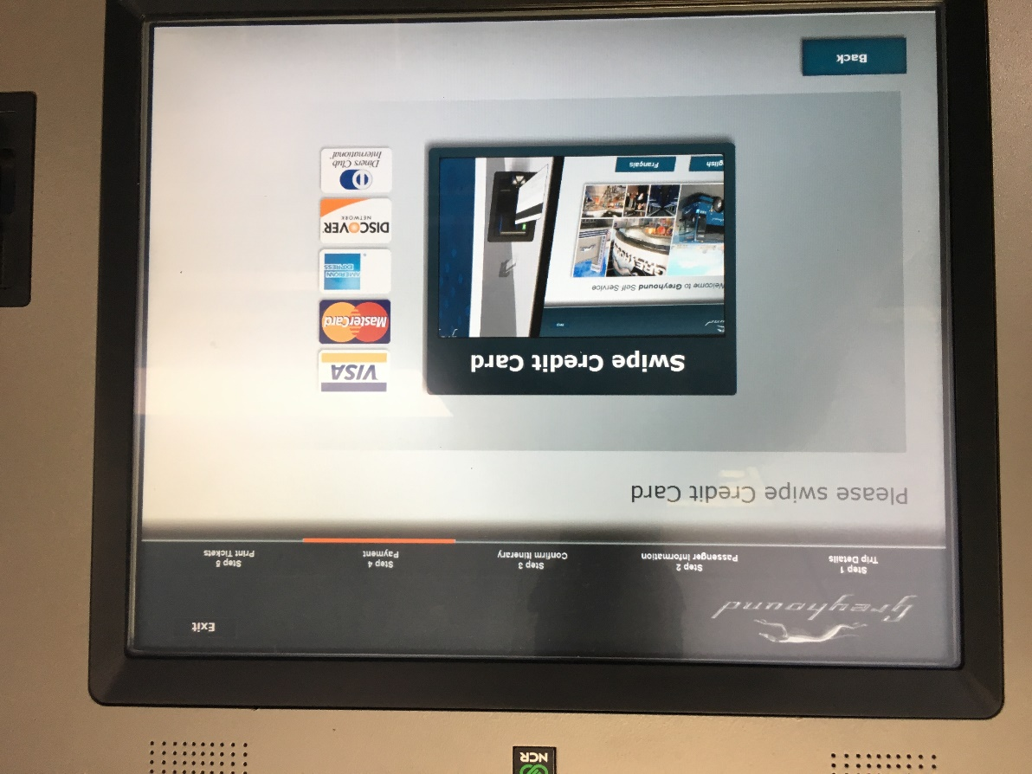
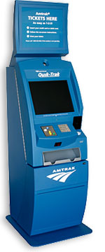
PURCHASING TICKETS USING THE QUIK-TRAK MACHINE
The Bus/Amtrak station does not have a ticket office. Instead, there is an electronic kiosk where you can purchase bus and train tickets (pictured left). Make sure you buy a ticket all the way to your final destination, rather than purchasing separate tickets for each leg of the journey.

The Quik-Trak machine uses a touch screen. To purchase tickets using the Quick-Trak Machine, follow these instructions:
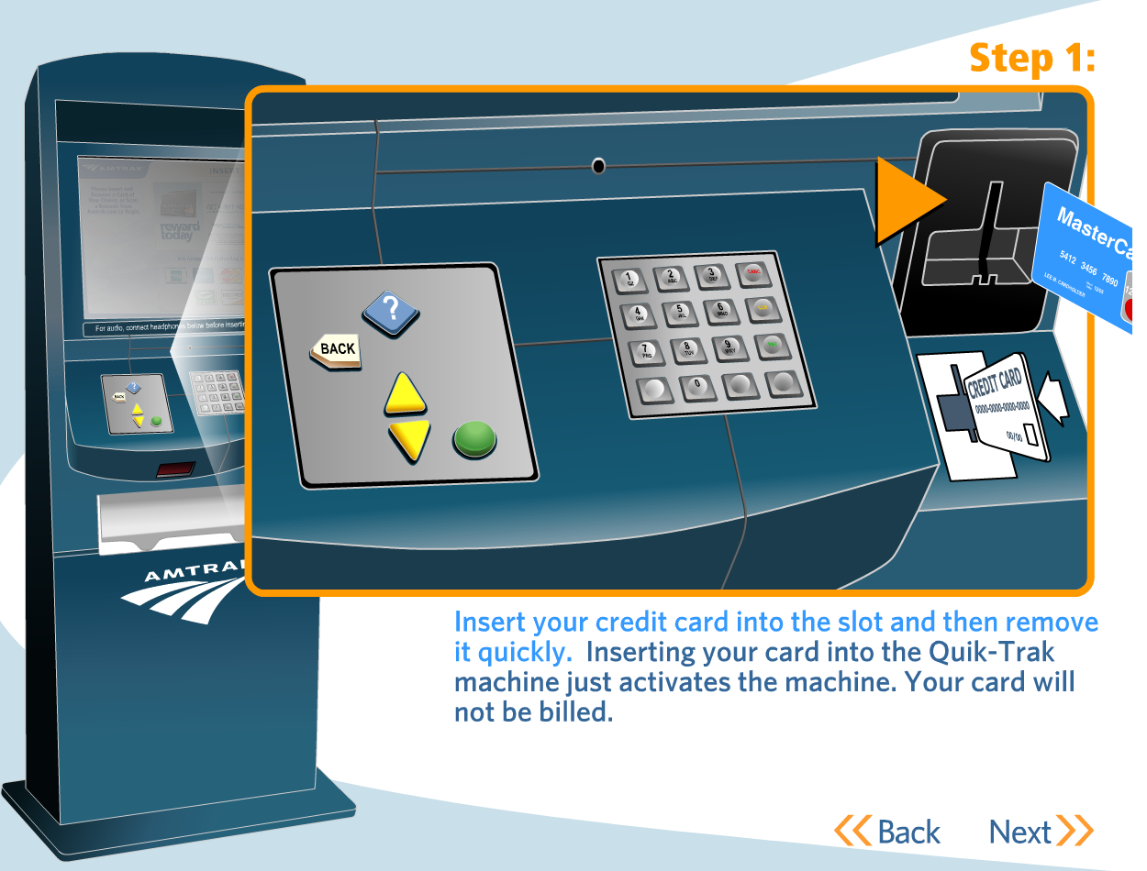

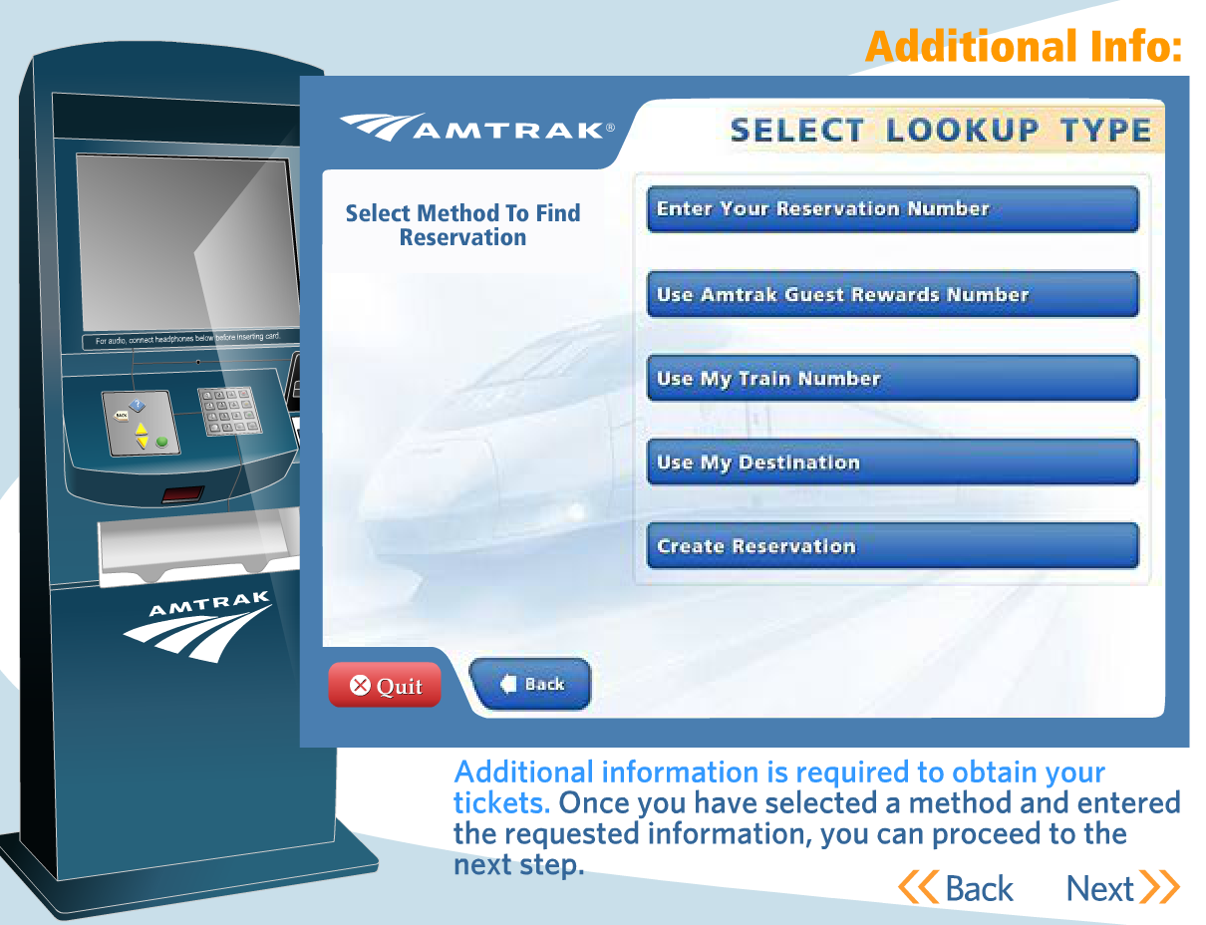

Step 2: Touch “Create Reservation” and select the location where you would like to go, and when.

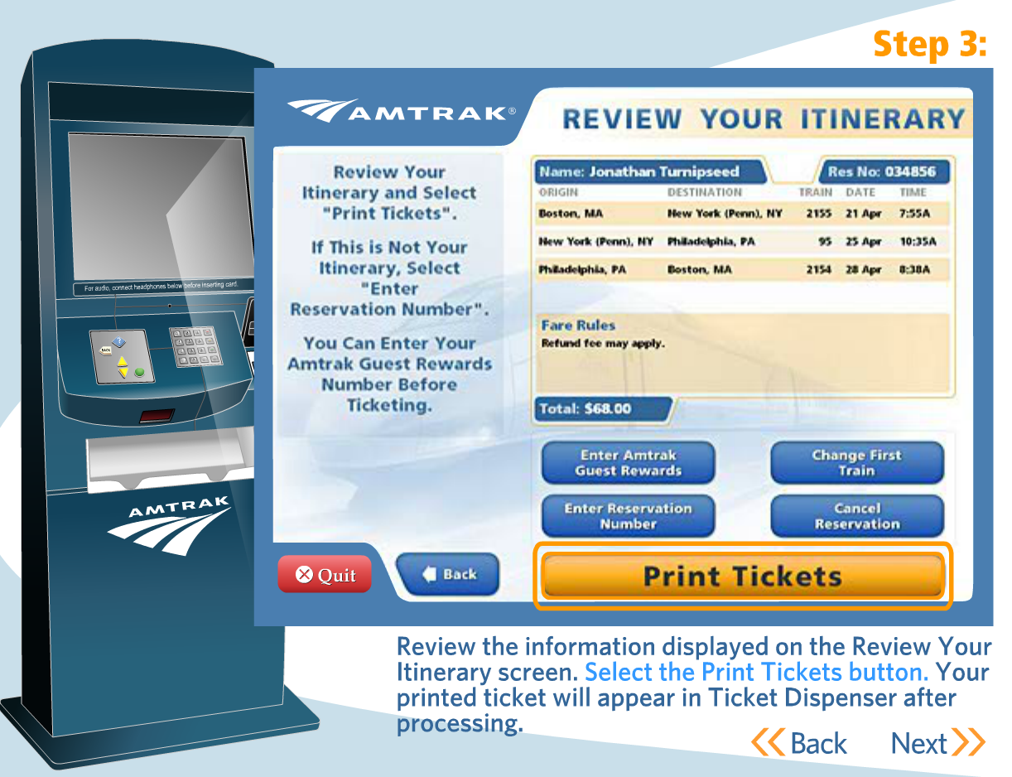

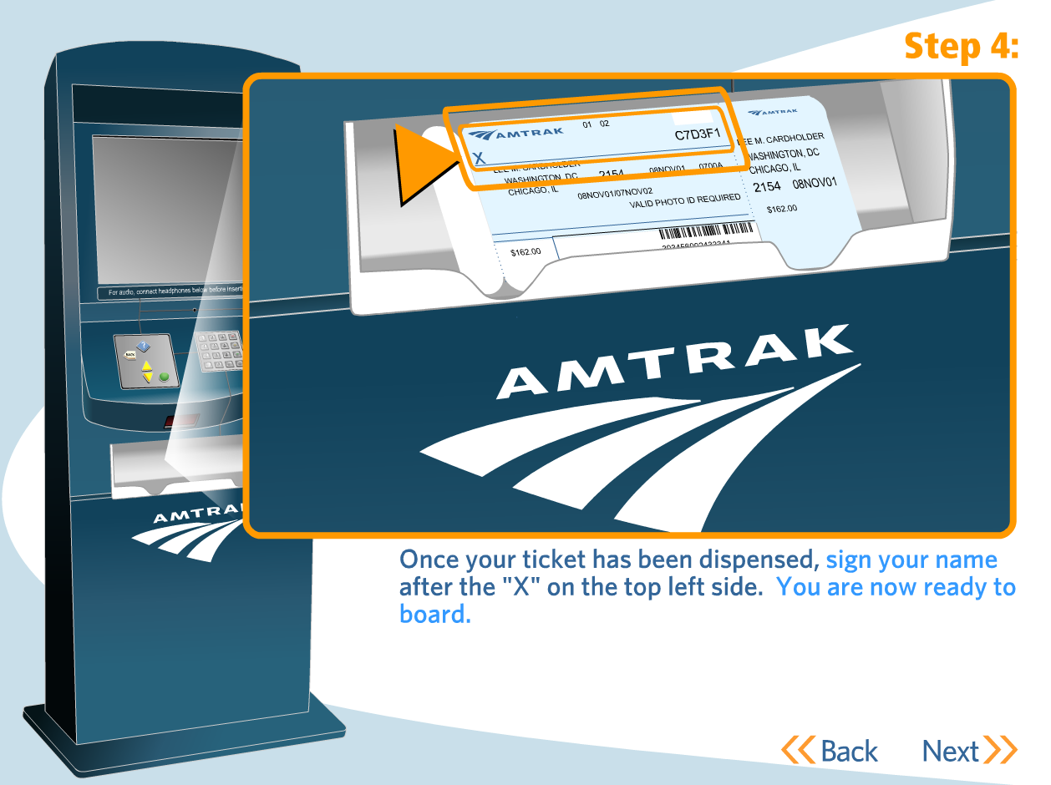

UNDERSTANDING YOUR AMTRAK TICKET AND TRIP
Your Amtrak ticket should look like one of the following shown below. They list your name, departure and arrival location, departure and arrival time. To find the boarding gate where your train is leaving ask an Amtrak employee or look for a monitor that lists it. These monitors will usually list the boarding gate 15 minutes before the departure time of the train. Make sure to get on your train as soon as possible - some trains will not let you on if you don’t board 10 minutes before the departure time. You may have to get on multiple trains to get to your destination. For part of your Amtrak trip you may have to take a Thruway Bus. If you cannot find something make sure to talk to people. Try to find someone who works at Amtrak, but you can always ask for help from a stranger.
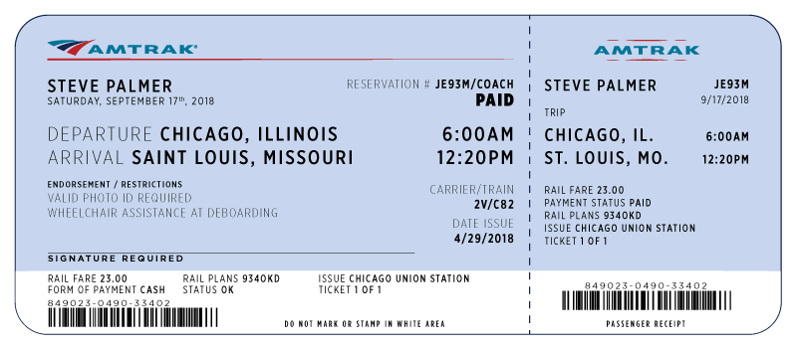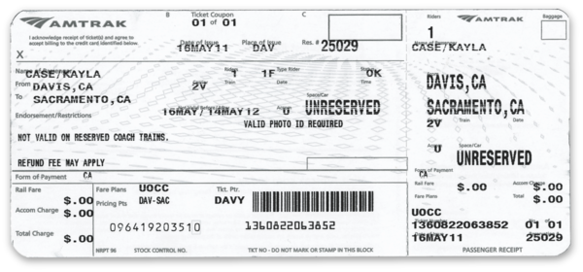

TO BAY AREA: TRAINS FROM SUISUN/FAIRFIELD STATION TO RICHMOND:
To get from Suisun/Fairfield to the Bay Area, the most reliable route is to take a train to Richmond, and then get on the BART. At 8:19 am, 8:59, and 9:49, get on the WESTBOUND train, known as the “Capitol Corridor.” Ride for 35 minutes, and get off at the second stop, Richmond. Here’s the WEEKDAY schedule:
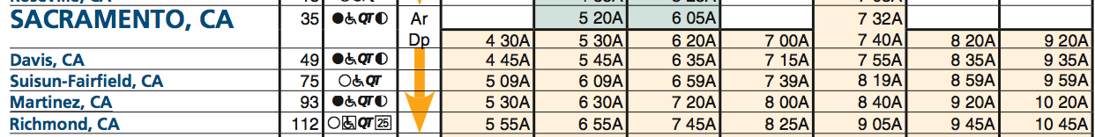

The schedule for this train is different on the weekend. Here’s the WEEKEND schedule:
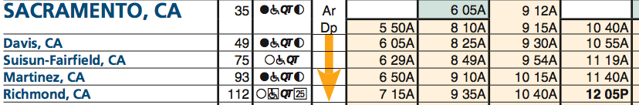

TO BAY AREA BY BUS: Here is the schedule for getting to Oakland from the Suisun/Fairfield stop.
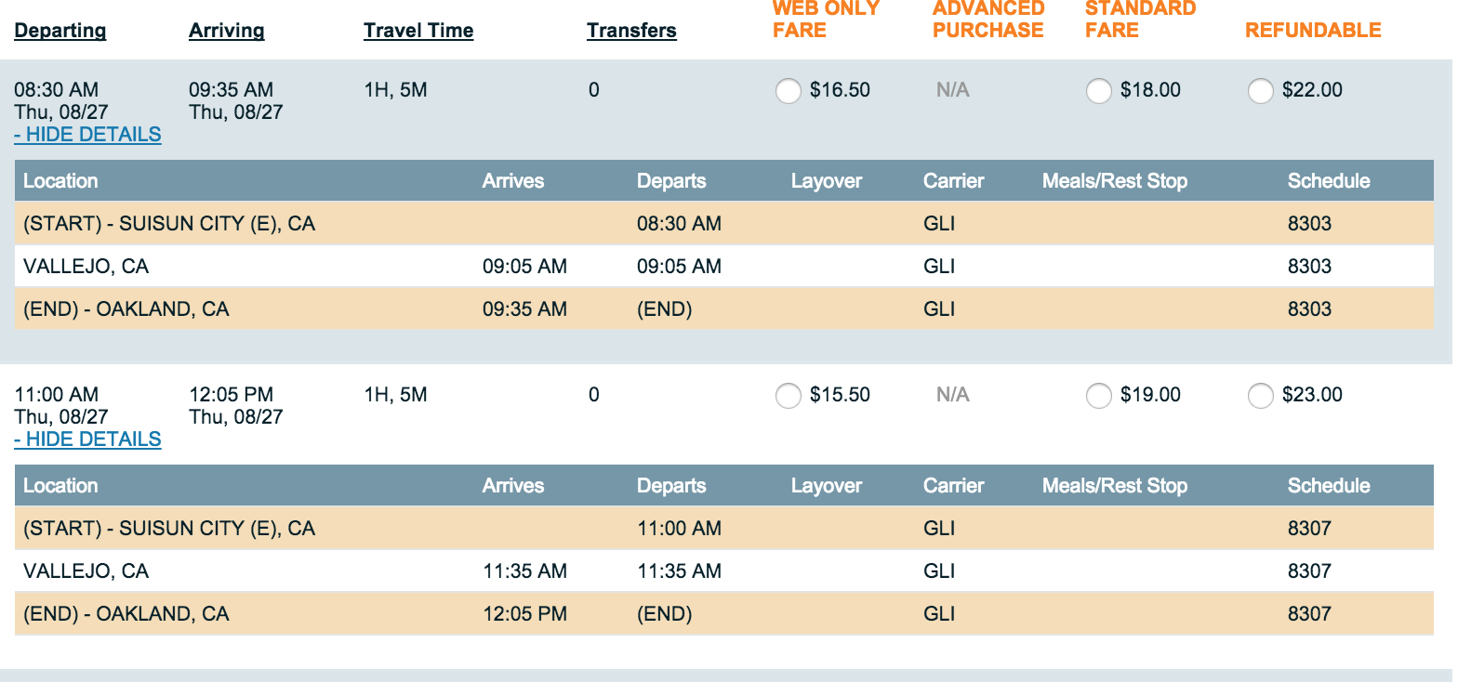

TRAVEL IN THE BAY AREA USING BART: Once in Richmond or Oakland, you can transfer to BART.
BART CARD: This a BART card (pictured left). Insert it into the turnstile (pictured below) on both entry and exit.

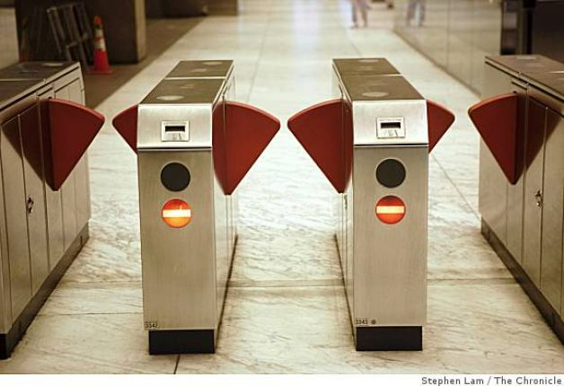

Once you exit, the funds are removed based on the length of your travel. You can know how much money remains on your card by looking next to the arrow, where the remaining amount is printed.

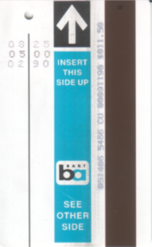

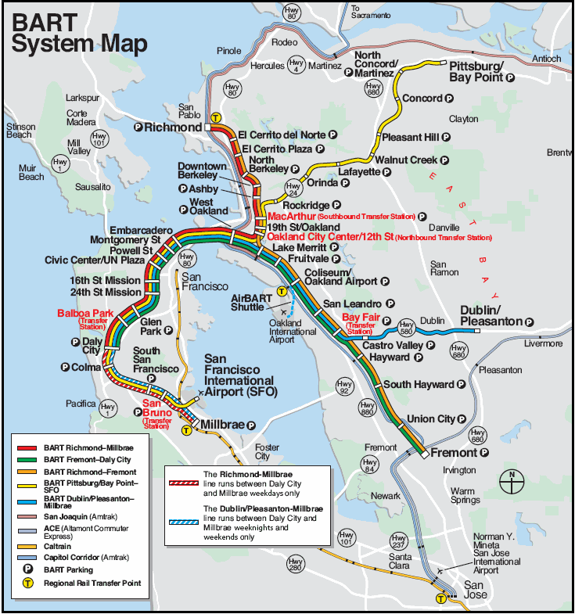
Here is a map of the BART system.
TO BAKERSFIELD BY TRAIN: TRAINS FROM SUISUN/FAIRFIELD STATION TO BAKERSFIELD:
To get from Suisun/Fairfield to Central California, the most reliable route is to take a train to Martinez, then take a train to Bakersfield. When you buy your train ticket, purchase the ticket all the way to Bakersfield, and make sure that it corresponds to this schedule. The trip to Bakersfield will cost $45.

At 8:19 am, 8:59, and 9:49, get on the WESTBOUND train, known as the “Capitol Corridor.” Ride this for twenty minutes, and get off at the first stop, Martinez. Here’s the WEEKDAY schedule:

The schedule for this train is different on the weekend. Here’s the WEEKEND schedule:

At 10:54, get on the SOUTHBOUND train from Martinez, known as the “San Joaquin.” Ride this for five hours, and get off in Bakersfield. Here’s the schedule for weekdays and weekends:
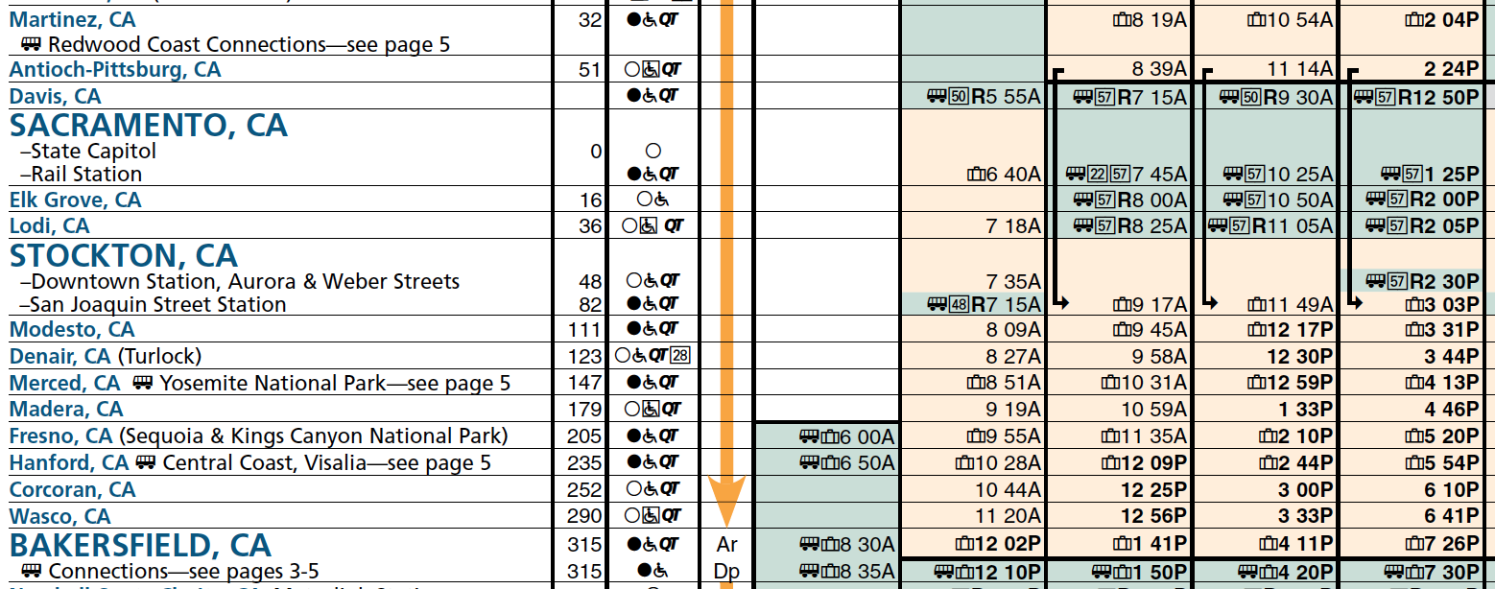

TO BAKSERSFIELD BY BUS: Here is the schedule for getting to Bakersfield by bus. Cost: $62.
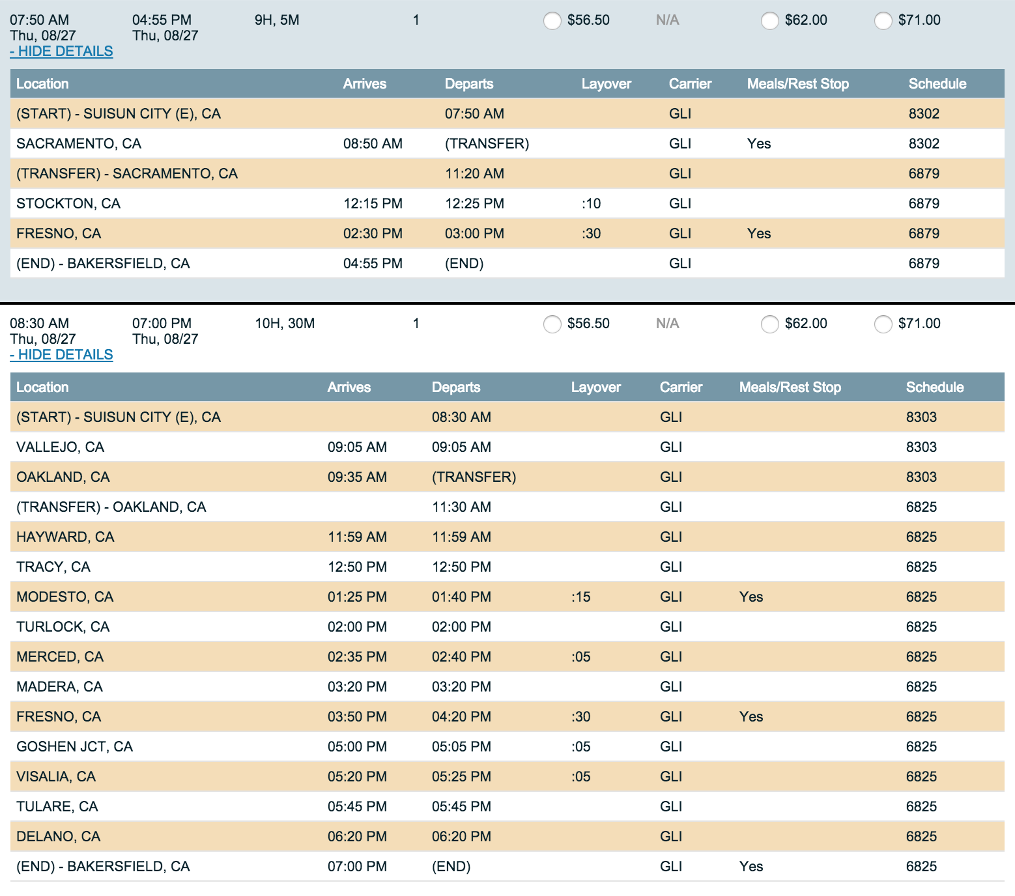

TO SACRAMENTO: TRAINS FROM SUISUN/FAIRFIELD STATION TO SACRAMENTO:
To get to Sacramento, CA, take the EASTBOUND train, known as the “Capitol Corridor.” The schedule for this train is different on the weekends and holidays. The trip to Sacramento will cost $16

On a WEEKDAY, get on the train at 8:53 am. Ride for one hour. Here’s the schedule:

On a WEEKEND or HOLIDAY, get on the train at 8:58 am. Here’s the schedule:
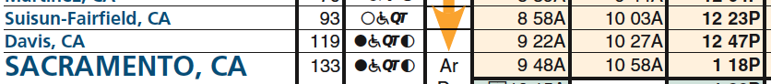

BUS TRAVEL TO SACRAMENTO: Here is the bus schedule to Sacramento.
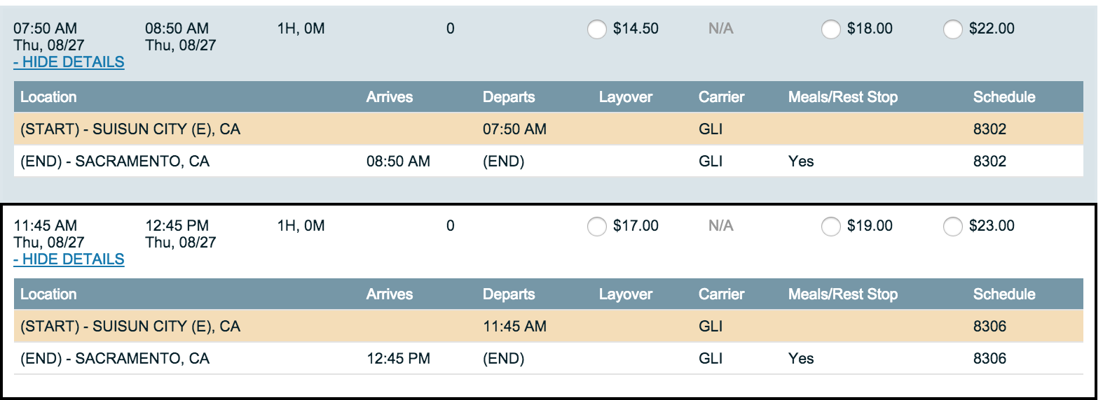

TO LOS ANGELES: TRAINS FROM SUISUN/FAIRFIELD STATION TO LOS ANGELES:
To get from Suisun/Fairfield to Southern California, the most reliable is to take a train to Martinez, then take a train to Bakersfield, and then a bus to Los Angeles. When you buy your train ticket, purchase the ticket all the way to Los Angeles, and make sure that it corresponds to this schedule. Using the route in this packet, the trip to Los Angeles will cost $78.

At 8:19 am, 8:59, and 9:49, get on the WESTBOUND train, known as the “Capitol Corridor.” Ride this for twenty minutes, and get off at the first stop, Martinez. Here’s the WEEKDAY schedule:

The schedule for this train is different on the weekend. Here’s the WEEKEND schedule:

At 10:54, get on the SOUTHBOUND train from Martinez, known as the “San Joaquin.” Ride this for five hours, and get off in Bakersfield. Here’s the schedule for weekdays and weekends:

At 4:11pm in Bakersfield, you have to transfer to a bus to Los Angeles. Here’s the schedule:
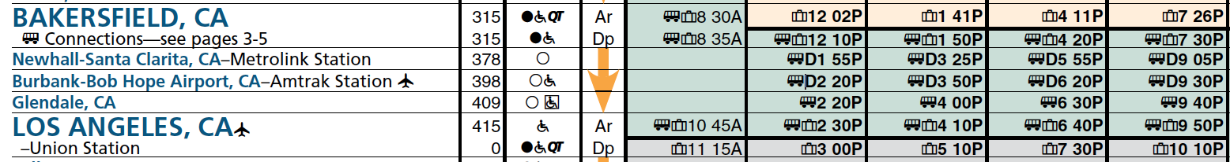
You will arrive at Union Station in Los Angeles at 6:40 pm.

BUS TRAVEL TO LOS ANGELES: Here is the bus schedule to Los Angeles. It will cost approximately $62.

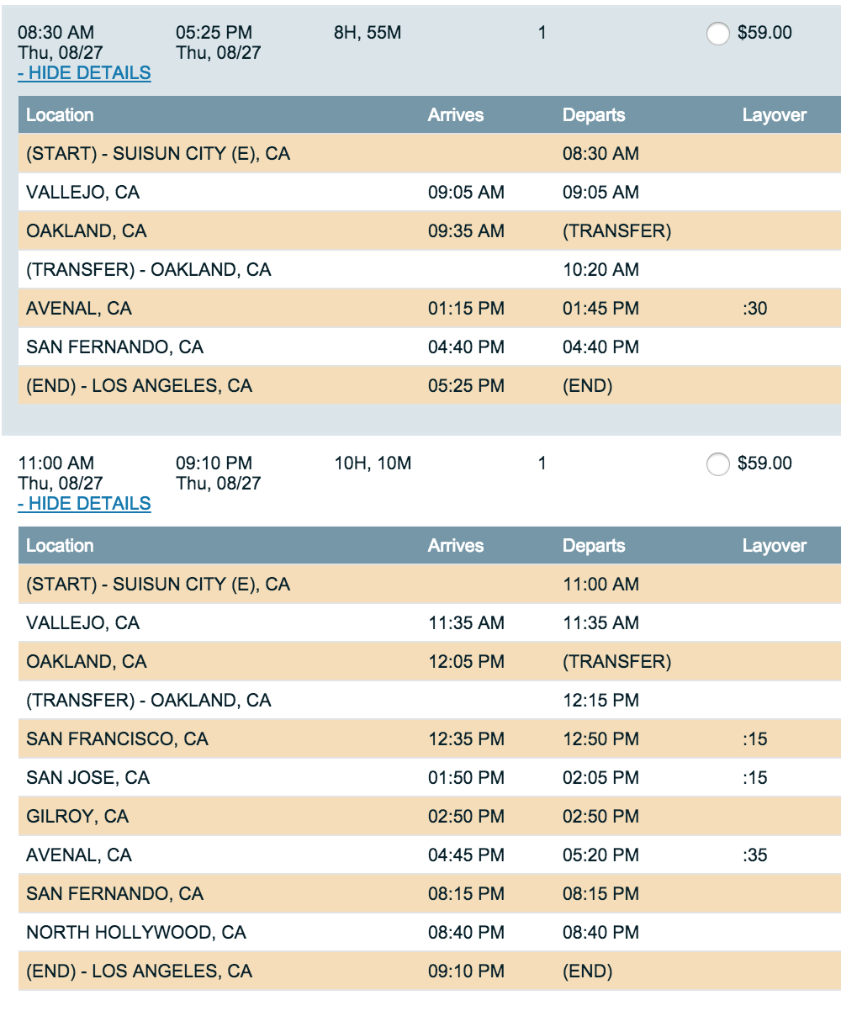

TRAVEL AROUND LOS ANGELES AREA USING METROLINK:

Once you make it to Los Angeles, you can get around the area using MetroLink:

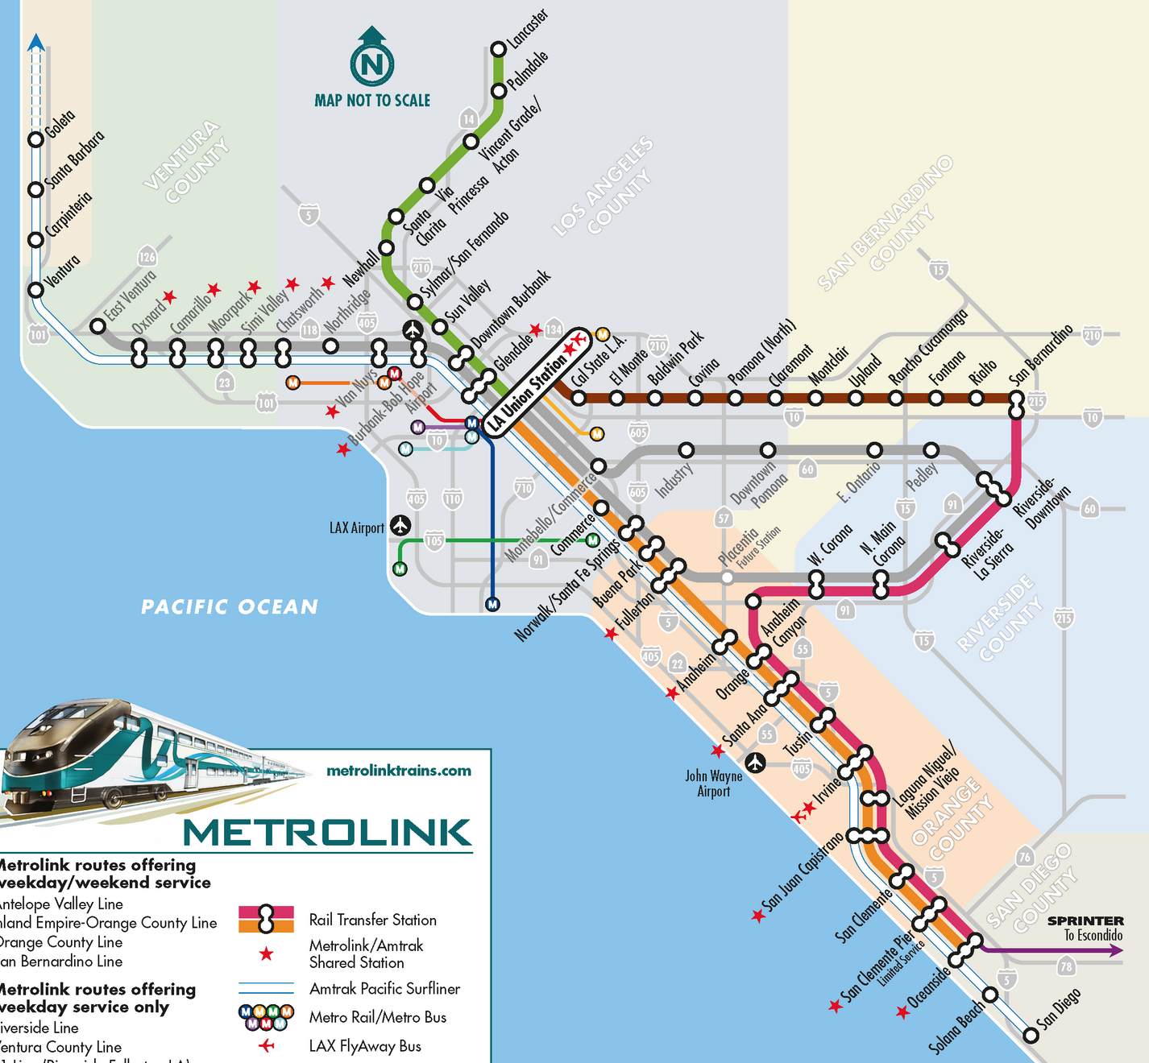

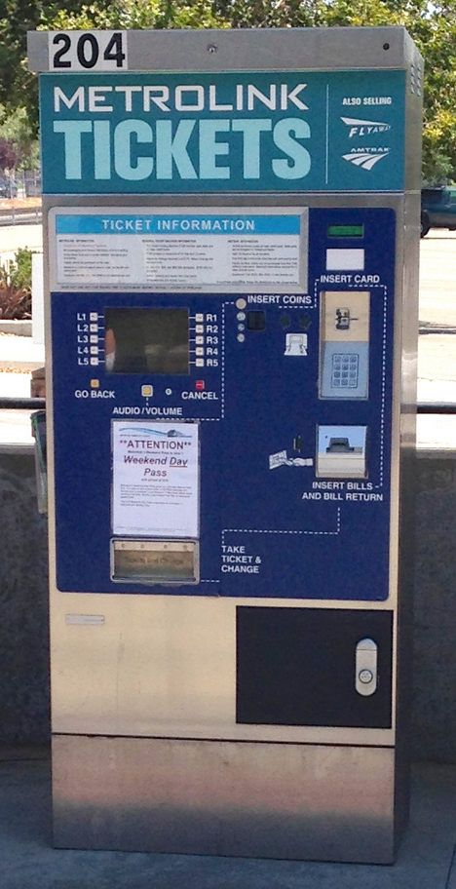
Purchasing Metrolink Tickets with Ticketing Machine:
Metrolink tickets are not sold onboard the train, and must be purchased prior to barding the train. Ticket vending machines (pictured right) are located on Metrolink train platforms. To purchase a ticket, follow these instructions:
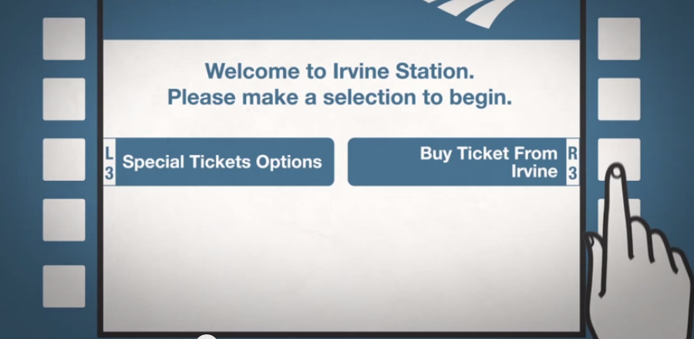
Step 1: Using the buttons surrounding this screen, select “Buy Ticket From Los Angeles”

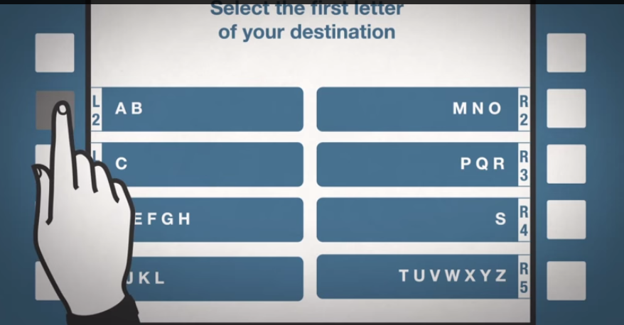

Step 2: Select the first letter of your destination.

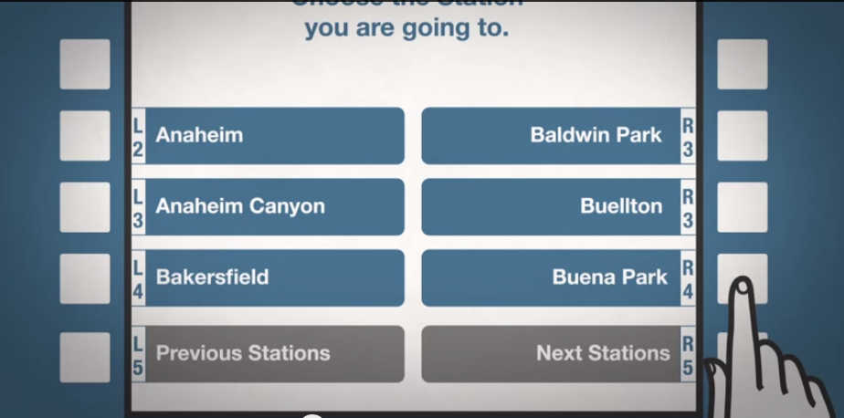
Step 3: Select your destination.
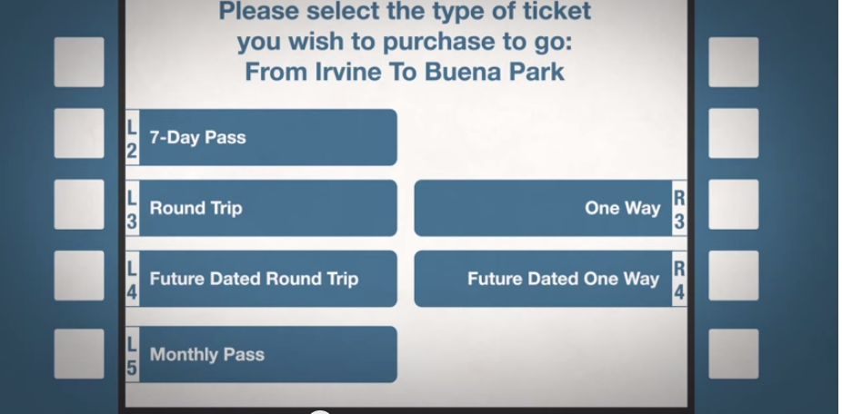

Step 4: Select One Way trip.

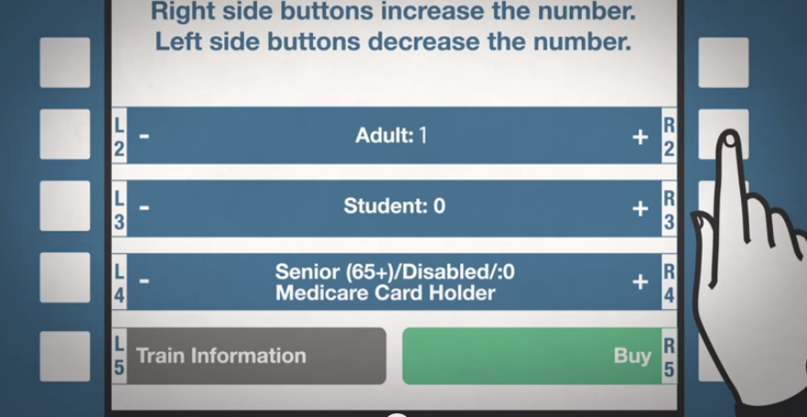
Step 5: Select the ticket type. If you are over 65 or disabled, be sure to get a reduced fee ticket.

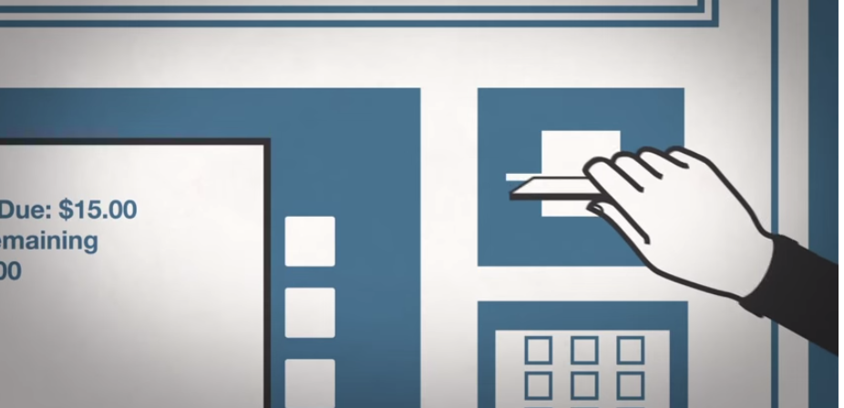
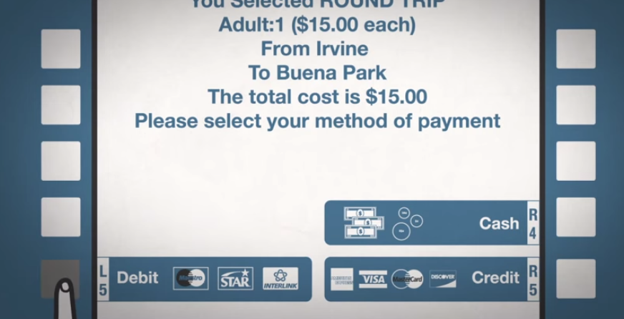
Step 6: Select “Credit” as your payment type and put your gate money card into the machine.

TRAINS FROM LOS ANGELES TO SAN DIEGO
From Los Angeles, you can get to San Diego by taking the “Pacific Surfliner.” If you have arrived in Los Angels at 6:40 pm, you can get the train to San Diego at 7:10 pm and 7:20 pm. The trip to San Diego will cost $90, including travel from Los Angeles.

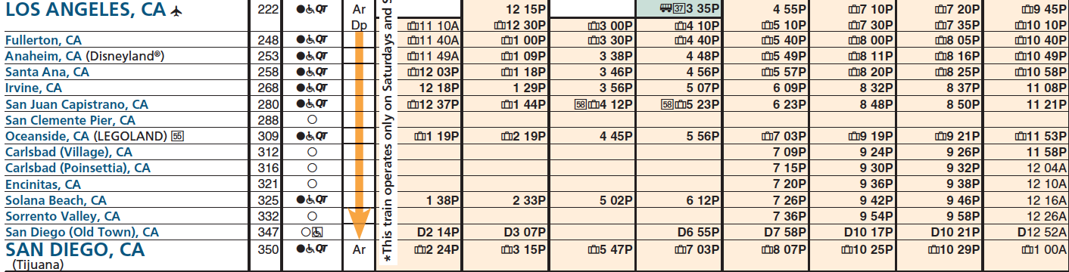

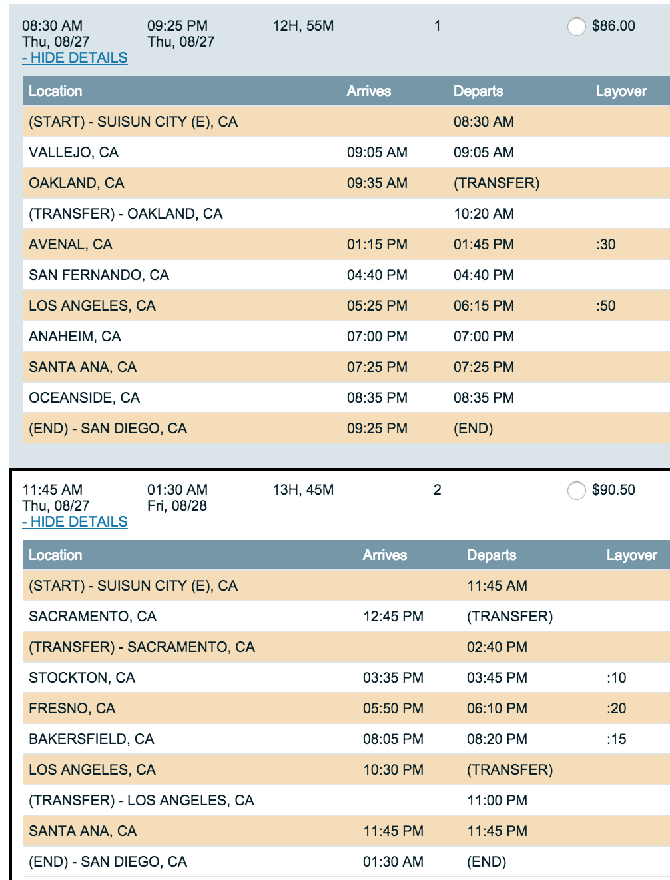
BUS TRAVEL TO SAN DIEGO: Here is the bus schedule to San Diego. Cost $92.

EMERGENCY SERVICES
These service providers can help you in the event of a problem:

SACRAMENTO:  For all services, dial 2-1-1 on any phone.  Emergency Shelters for men:  Union Gospel Mission  400 North Bannon Street, Sacramento, CA 95814  Ph. (916) 447-3268  Provides a seven 7-night stay for single men. Be there at the black metal gate by 5:30 p.m. for a first come/first serve basis. You can have 7 nights in, then stay out for three nights, and come back for 7 more days. Preference usually given to "first timers" or new people, so let the staff know if this is your first time.  Salvation Army  200 North B Street, Sacramento, CA 95814  Ph. (916) 442-0331 x0  Emergency shelter provided for single men or women only. You must be at their B street lobby at 1:00 p.m. for placement onto the waiting list. Offers a 30 to 60 day shelter assisting in employment and housing independence.  Adult Shelter VOA  1400 North A Street, Building B, Sacramento, CA 95814  Ph. (916) 448-5507  You must show up the first time to have your name placed on the waiting list. Check in each day 9:00 a.m. to 12:00 p.m. - Intake is at 1:00 p.m. Call in each day for check-in after your name is on the list. When your name is close to the top, then show up or if you call in the staff will tell you to show up if you may receive a bed space. | LOS ANGELES: For all services, dial 2-1-1 on any phone.  Shelters:  Year Round Emergency Shelter  (800) 548-6047,  TTY: (800) 660-4026
BAKERSFIELD: For all services, dial 2-1-1 on any phone.

Shelter and Food:
Bakersfield Homeless Center
1600 East Truxtun Avenue, Bakersfield, CA
(661) 322-9199
OAKLAND  Food:  Alameda County Community Food Bank  Call 510-635-3663 to get registered to pick up food.  Their address is 7900 Edgewater Drive Oakland, CA 94621  Shelters: Dial 2-1-1 on any phone, and someone will direct you to a shelter. Also try:  City Team  722 Washington St., Oakland, CA.  510.452.3758 and wait to dial 26  Healthcare: Dial 9-1-1 if it is an emergency.  1411 E 31st St, Oakland, CA ‎  (510) 437-4800 ‎ | SAN DIEGO: For all services, dial 2-1-1 on any phone.
SAN FRANCISCO
Food: Glide serves over 1,000 meals daily.
Glide Memorial Church
330 Ellis St.
415-674-6000

Shelter: Dial 2-1-1 on any phone, and someone will direct you to a shelter.

Healthcare: Dial 9-1-1 if it is an emergency.
San Francisco General Hospital
1001 Portrero Ave.
San Francisco, CA 94110
415-206-8000

